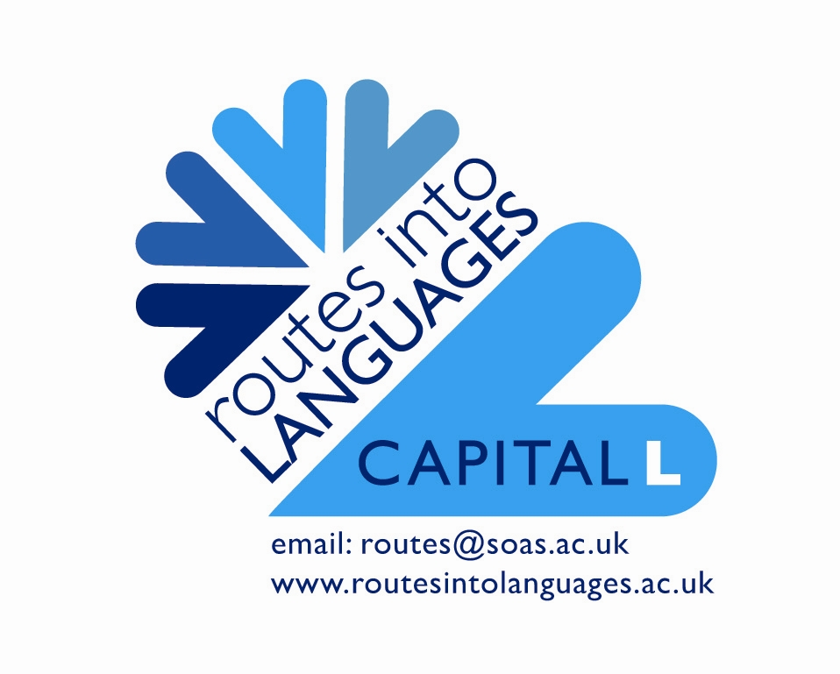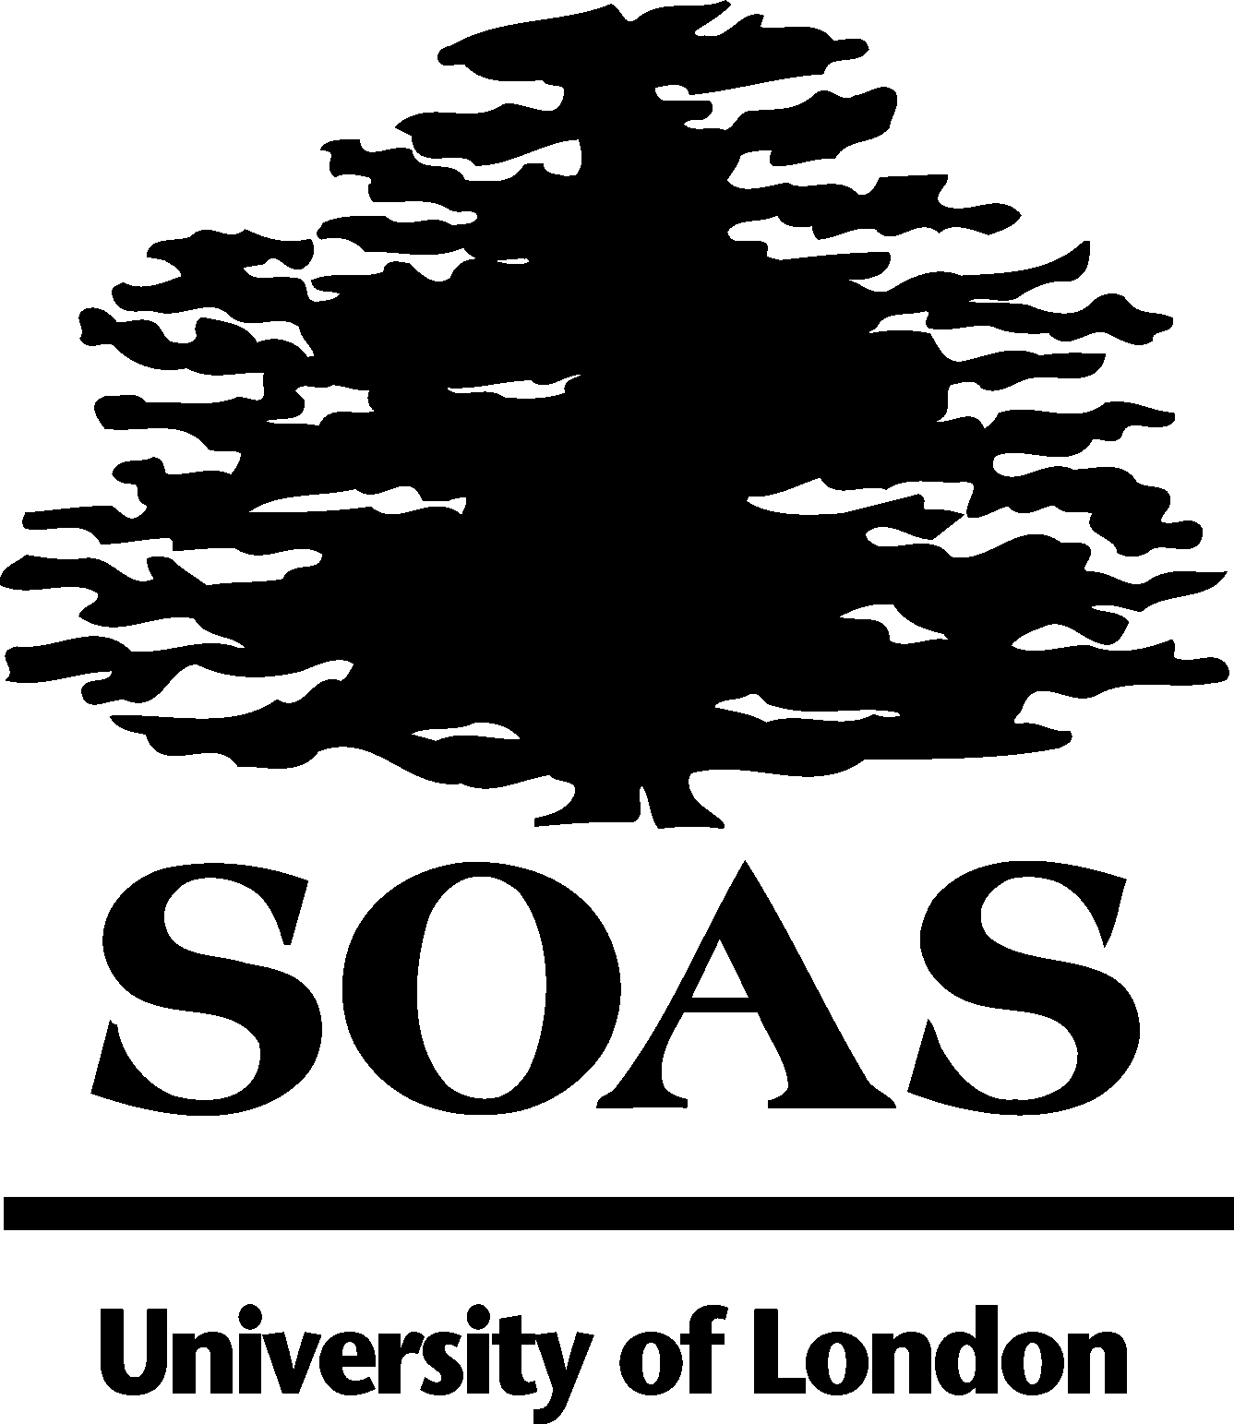

“Community Language Learning: From Three Different Perspectives”

Emine Çakir Sürmeli & Julien Boast
School of Oriental and African Studies

School of Oriental and African Studies

The School of Oriental and African Studies (SOAS) is a college of the University of London and the only Higher Education institution in the UK specialising in the study of Asia, Africa and the Near and Middle East.

Uniquely combining language scholarship, disciplinary expertise and regional focus, it has the largest concentration in Europe of academic staff concerned with Africa, Asia and the Middle East.

Turkish Immersion Week

In July 2009, the Learning & Teaching Unit at SOAS held an immersion week for Turkish community language learners in years 9-11. The week was held in conjunction with Routes into Languages-Capital L and the Department of the Languages and Cultures of the Near & Middle East. The aims of the Immersion Week were to:

- develop written skills
- raise the profile of community languages
- explore political, cultural and historical topics related to Turkish
- raise aspirations

Please see overleaf for a suggested programme for our next Immersion Week, taking into account what we learnt this year.

Below is an evaluation from two students who attended the week:

“SOAS üniversite’de geçirdiğimiz süre çok değerliydi bizim için. Yeni arkadaşlarla tanısdık Türkiyenin her yerinden ve hepsi birbirinden güzel kişiliklere sahipti. Orda geçirdiğimiz sürede bize üniversiteli gibi davrandılar ve bu çok hosumuza gitti çünkü üniversiteli olmakla ilgili çok sey öğrendik. Ayrıca, gördüğümüz dersler, Türkce dili, Türkiye tarihi, Türkiye politikasi ve Türk müzikleriydi. Her dersten ayrı birşey öğrendik ve eğlendik, geleceğimiz için çok güzel bir deneyim oldu.

The time that we spent in SOAS University was very special for us. We made new friends from all parts of Turkey and they all had very nice personalities. During the time we spent in university we were treated like university students which we appreciated because we learnt a lot about what life is like in university. In addition, the lessons we had were Turkish language, Turkish history, Turkish politics and Turkish music. We enjoyed it and learnt a lot in every lesson we had. It was a good experience for our future.”

For further information please contact Julien on jb73@soas.ac.uk
Proposed Programme for Future Immersion Weeks

Day 1 | Day 2 | Day 3 | Day 4
10am-10.30am  Introduction and welcome to SOAS | 10am-10.30am  Scavenger hunt quiz | 10am-10.30am  Scavenger hunt quiz | 10am-10.30am  Physical learning game/activity  (eg. charades)
10.30am-11.30am  Language session 1 | 10.30am-11.30am  Languages in Action  Turkey and Turkish in Music | 10.30am-11.30am  Language session 5 | 10.30am-11.30am  Language session 7
11.30am-11.45am  Break | 11.30am-11.45am  Break | 11.30am-11.45am  Break | 11.30am-11.45am  Break
11.45am-12.45pm  Language session 2 | 11.45am-12.45pm  Language session 3 | 11.45am-12.45pm  Language session 6 | 11.45am-12.45pm  Ambassador-led session  [Careers/IAG focus]
12.45pm-1.30pm  Lunch | 12.45pm-1.30pm  Lunch | 12.45pm-1.30pm  Lunch | 12.45pm-1.30pm  Lunch
1.30pm-2.15pm  Campus Tour | 1.30pm – 2.30pm  Language session 4 | 1.30pm-2.30pm  Languages in Action  Turkey and Turkish in Politics  [incorporating group work] | 1.30pm-3pm  Project work session
2.15pm-3.15pm  Project work session  [2 ambassadors per group of 6 students] | 2.30pm-2.45pm  Physical learning game/activity  (eg. charades) | 2.30pm-3.30pm  Project work session | 1.30pm-3pm  Project work session
 | 2.45pm-3.30pm  Languages in Action  Turkey and Turkish in History  [incorporating group work] | 2.30pm-3.30pm  Project work session | 3pm-4.30pm  Presentations and celebration

