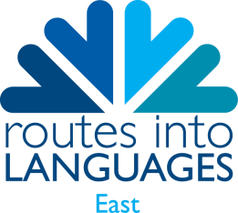
National Year 7 Spelling Bee

The aim of the Spelling Bee is for students in Year 7 to practise and improve their vocabulary, spelling and memory skills in a foreign language (French, Spanish and German) and to raise the profile of language learning through a class, school and regional competition. :
Term 1 – Individual class competition
Term 2, half term – Whole school competition
Term 2, end – Regional Competition
Term 3 – National Competition, 8th July (tbc)
How it works:
- Students will be given 50 words to learn at the first stage of the competition and a further
50 words will be added at both subsequent stages of the competition. Vocabulary will be
relevant to the curriculum. For the National Final words will be 2012 related?
- The competition should be launched in school in the autumn term and time should be spent
teaching and practising the alphabet in the foreign language (paying attention to
describing letters with accents, etc..).
- Unlike in a monolingual Spelling Bee, students will be given the word in English, They
will first have to translate it into the foreign language and then spell it out correctly using
the alphabet in the foreign language..
- When participating, students will be given one
minute to correctly spell as many words as possible.
- Words should be allocated in random order.
The names of the winners at each stage of the competition should be submitted to routes@anglia.ac.uk so that they can receive acknowledgement for their achievements via a certificate.
Finalists will be entered into the National Spelling Bee Final to be held on Friday 8th july in Cambridge
If you’d like your year 7s to compete, please complete the registration form below and email it to routes@anglia.ac.uk

REGISTRATION FORM

TEACHER NAME:
EMAIL:
SCHOOL:

ADDRESS:

NUMBER OF PUPILS PARTICIPATING:

THE FOLLOWING PUPILS WILL BE PARTICIPATING:

THE WHOLE OF YEAR

HALF OF YEAR

GIFTED & TALENTED
OTHER (please specify) ______________________________________________
WE WOULD LIKE TO PARTICIPATE IN THE FRENCH/GERMAN/SPANISH SPELLING BEE (delete as applicable*)

*schools may offer up to 3 languages with 4 pupils from each school invited to the Regional Final

