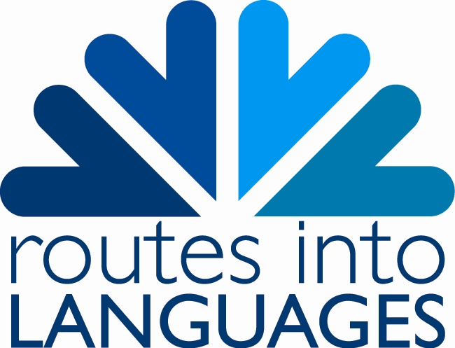

Routes into Languages
Parental Consent Form for Use of Images of Children and young people

I/we,………………………………………………………the parent(s)/guardian(s) of:

(child’s full name)……………………………………………………………………………………………..

(child’s full name)……………………………………………………………………………………………..

(child’s full name)……………………………………………………………………………………………..

hereby give ‘Routes into Languages’ permission to use any still and/or moving images such as video footage, photographs and/or frames and/or audio footage depicting my/our children named above,

For any of the following uses:

- Advertisements, marketing, leaflets, website, or any other use such as training, educational or publicity purposes.

The above consents will apply throughout England and be for an indefinite period.

Signed………………………………….……….Date…………………………………………………………….

Signed………………………………….……….Date…………………………………………………………….

Address……………………………………………………………………………………………………………….

…………………………………………………………………………………………...........................

Postcode………………………………………………..

This information will be used for Routes Into Languages purposes only. Your details will not be released to third parties, or used for any purpose not related to Routes activities. Data held by Routes into Languages is subject to the provisions of the Data Protection Act 1998.

Routes into Languages is an £8 million group of projects funded by the Higher Education Funding Council for England and the Department for Children, Schools and Families and aims to increase the take up of languages at GCSE and beyond.

For further information on the Routes into Languages project visit www.routesintolanguages.ac.uk

