|  |  |  |  |
| --- | --- | --- | --- |
| MCBF logo | MMU_logo | routesnw logo | Anglia_Ruskin_Ca&Ch_CMYK |

Mother Tongue

Other Tongue

In June2014, regional winners from across the country will convene at MMU for a national celebration of the diverse range of languages and cultures that make up the United Kingdom today.

A multilingual poetry competition that celebrates cultural diversity and the many languages currently spoken in schools across the UK.

Mother Tongue Other Tongue is a national project, led by Poet Laureate Carol Ann Duffy, Director of the Manchester Writing School at MMU. An idea originally developed by the Faculty of Humanities, Languages and Social Science at MMU and Routes into Languages North West, this exciting project is being rolled out nationally as this year’s Laureate Education Project, with regional events and competitions taking place throughout 2015. In the Eastern region the competition is being led by Routes into Languages East at Anglia Ruskin University, Cambridge.

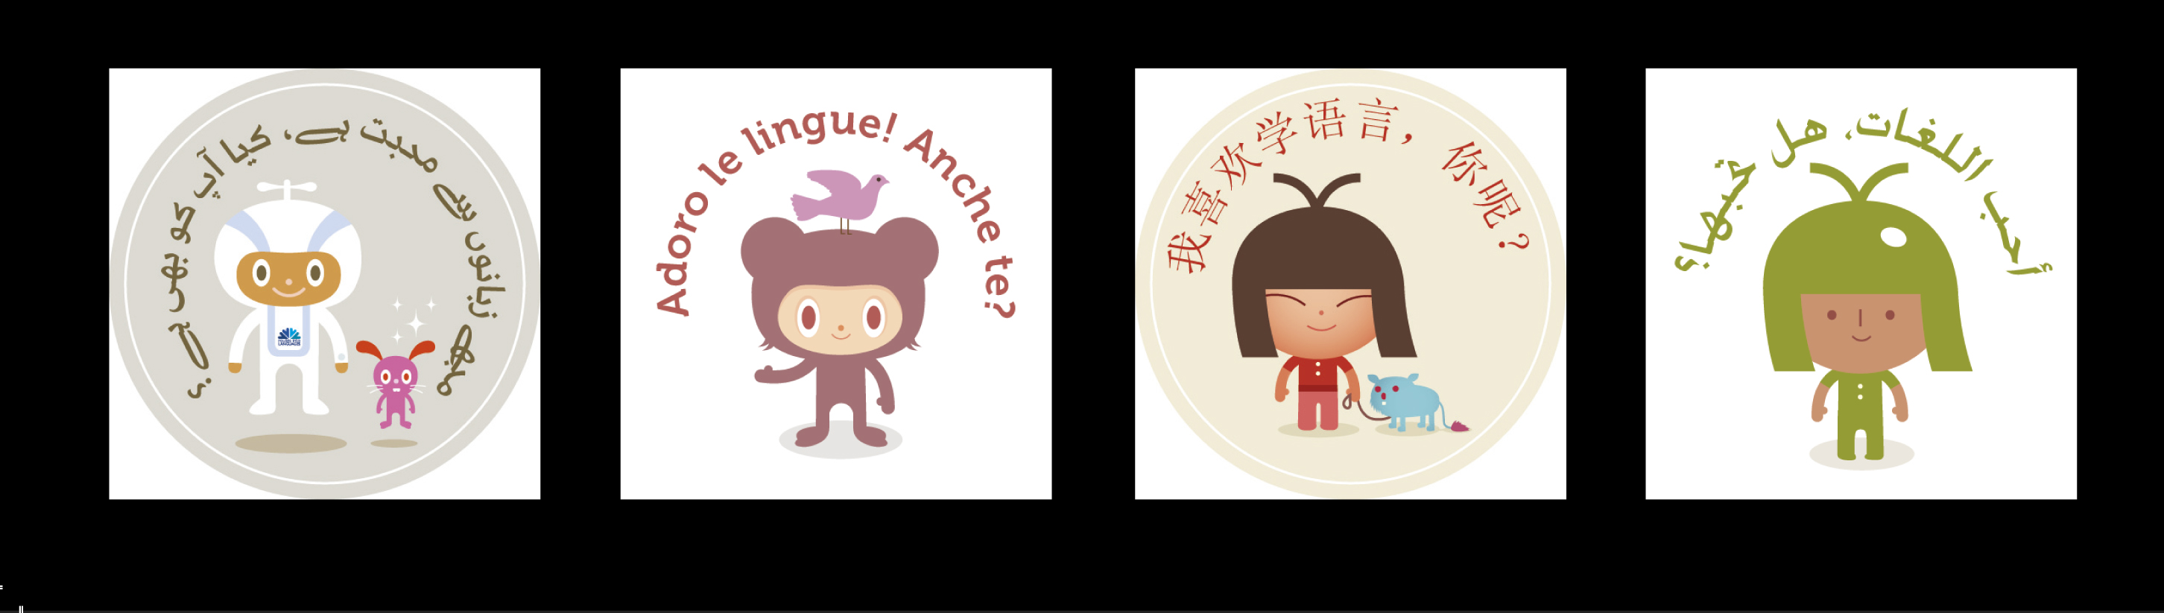

**Mother Tongue** entries will be in two parts: The first part is the poem. This can be an original, creative piece, or a poem or song that is ‘remembered’ – i.e. something in your first language that you recall, or that has been told to you by a relative. This can be in any language but English. The second part should be a short explanation of the inspiration behind the piece, where it comes from, or why it is important to the person submitting it (no more than half a page). This part must be written in English and is the part your entry will be judged on.

**Other Tongue** entries must be an original poem written in a language that is not the first language spoken by the person writing it.

There are 2 deadlines this year.

For more information go to: https://www.routesintolanguages.ac.uk/east/activity/3728

EACH ENTRY MUST BE ACCOMPANIED BY AN ENTRY FORM:

|  |  |  |  |
| --- | --- | --- | --- |
| **Mother Tongue Other Tongue Competition Entry** | | | |
| School/Pupil Name\* | School/Pupil Address\* | | |
| Year Group: |
| Pupil Email/Phone Number (If entry not submitted by teacher) | | | |
| Teacher/Parent Name | | | Teacher/Parent Email (or phone number) |
| Group Names (if applicable) | | | |
| Forename(s) | | Surname | |
|  | |  | |
|  | |  | |
|  | |  | |
|  | |  | |
|  | |  | |
|  | |  | |
|  | |  | |
| Title of Piece: | | | |
| This is a Mother Tongue/Other Tongue entry (delete as applicable) | | | |
| Language of piece (for Mother Tongue entries): | | | |
| ***\*For office use only*** |  | | |
| ***Comments*** |  | | |

\* Give pupil details, if entry submitted alone, ie not by (class) teacher.