 |  | 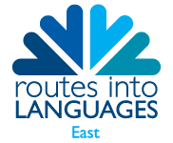 | 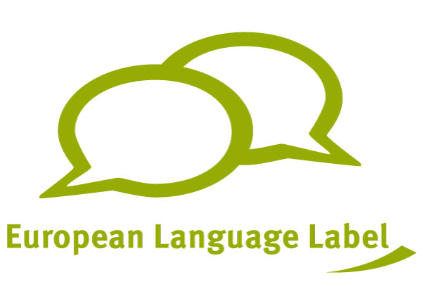

The Languages Challenge

What is the Languages Challenge?
The Languages Challenge was created by Vincent Everett of Northgate High School, Dereham to support and reward pupils who love languages and want to use them creatively in their own time. Pupils complete a series of activities, recording the evidence. On successful completion of the Languages Challenge, you will receive a certificate and can claim 10 hours for your Children’s University passport.

Who is the Languages Challenge for?
The Languages Challenge is for any pupil aged 11-14 who realises the importance of learning languages and can show commitment, creativity and enthusiasm for it. You can do tasks in any language that you are learning.

What do you have to do?
There are 7 categories: Learning the Basics, Using your Talents, Research, Culture, Creativity, Resources, and Futures. Each category has a choice of tasks. You must complete at least one task from each category. Tasks are worth 5, 10, 15 or 20 points. To successfully complete the Languages Challenge, you are aiming for a total of 100 points.

You must keep evidence of each task in a portfolio. This could be in the form of photographs, videos, or writing. You will also need to write up an overall self-evaluation explaining what you have achieved and what you have learnt. The whole portfolio will be submitted to your language teacher. Your school might choose to hold a Languages Challenge Celebration where you could choose one of your outcomes to be performed, shown or presented to parents and visitors.

What happens next?
Once you have decided to take on the Languages Challenge, you should look at the tasks and decide where to start. You could plan all of the tasks you want to do, or you could pick one and get started. When you complete a task, make sure you keep the evidence.

What happens when it is finished?
When you have completed your portfolio, submit it to your designated Languages Challenge teacher, who will complete the appropriate form and send it to Routes into Languages East. Pupils who successfully present evidence of completion of tasks worth 100 points from all 7 categories, will be given a Routes into Languages East Challenge certificate and 10 hours in their Children’s University passport
The Languages Challenge
Challenges | Points
Category 1. Learning the Basics  Experiment with different techniques for learning vocabulary  Produce a grammar guide. Use it to help other people and get feedback on how helpful it was and adapt it accordingly  Find resources to teach something in another language that you haven’t done before.  Teach someone else something that you have already learnt in another language | 10  10  5  5
Category 2. Using your Talents  Use the language you’re learning in an area where you have a talent: song, drama, sport, dance, web design, games, gardening, etc..  Run a successful languages club or event.  Pursue/investigate a topic of interest to you in another language.  Learn some Maths in French, German or Spanish with the Routes into Languages East LinguaMaths project (https://www.routesintolanguages.ac.uk/east/activity/3393) | 10  10  5  15
Category 3. Research  Investigate an element of culture, history or geography of a place that speaks the language you’re learning, or a famous person who speaks that language – in that language.  Find and follow instructions, in the language you’re learning, to make something – a recipe, a machine, a toy  Find out how to introduce yourself in 10 other languages that you didn’t know before | 10  10  5
Category 4. Culture.  Listen to music in a different language. Share what you find with your friends.  Watch foreign videos or films  Read on-line magazines for young people in your chosen language. Share what you find with your friends | 10  10  10
Category 5. Creativity.  Create computer resources for language learning. Demonstrate them to your teacher.  Write a story in a foreign language, or a poem. Share it with your friends or family.  Learn a joke in a foreign language and tell it to someone in their own language.  Create a video tutorial in a foreign language. It should show how to do something in an area where you have a talent.  Record or film yourself speaking a foreign language. Share it with friends or family.  Find a subject that interests you and create a blog on it in another language | 15  10  10  10  10  10
Category 6. Resources.  Use the library to find foreign language books and cds to read/listen to. Evaluate them and write a review for your school/language department website magazine or wall.  Set your phone/games console/user profile/family car satnav to a foreign language  Find ICT resources for language-learning. Evaluate different resources and write a review school/language department website magazine or wall. | 10  5  5
Category 7. Futures.  If you have a career you would love to pursue, investigate the opportunities that would open up if you could speak another language or travel abroad. How can having a language help you break into a job?  Investigate careers with languages. What opportunities are there for people with a language? What do people who study languages actually end up doing?  Interview a university student who is studying a language, or someone who has lived/worked abroad or uses a language in their job.  Investigate different types of University language courses:  Studying languages  Studying Languages and another subject together  Science/Engineering/Law/Business/Media etc courses that include study of a language.  Taking a language as an extra.  Spending a year studying abroad.  Universities that expect or require a language at GCSE. | 10  5  5  5

