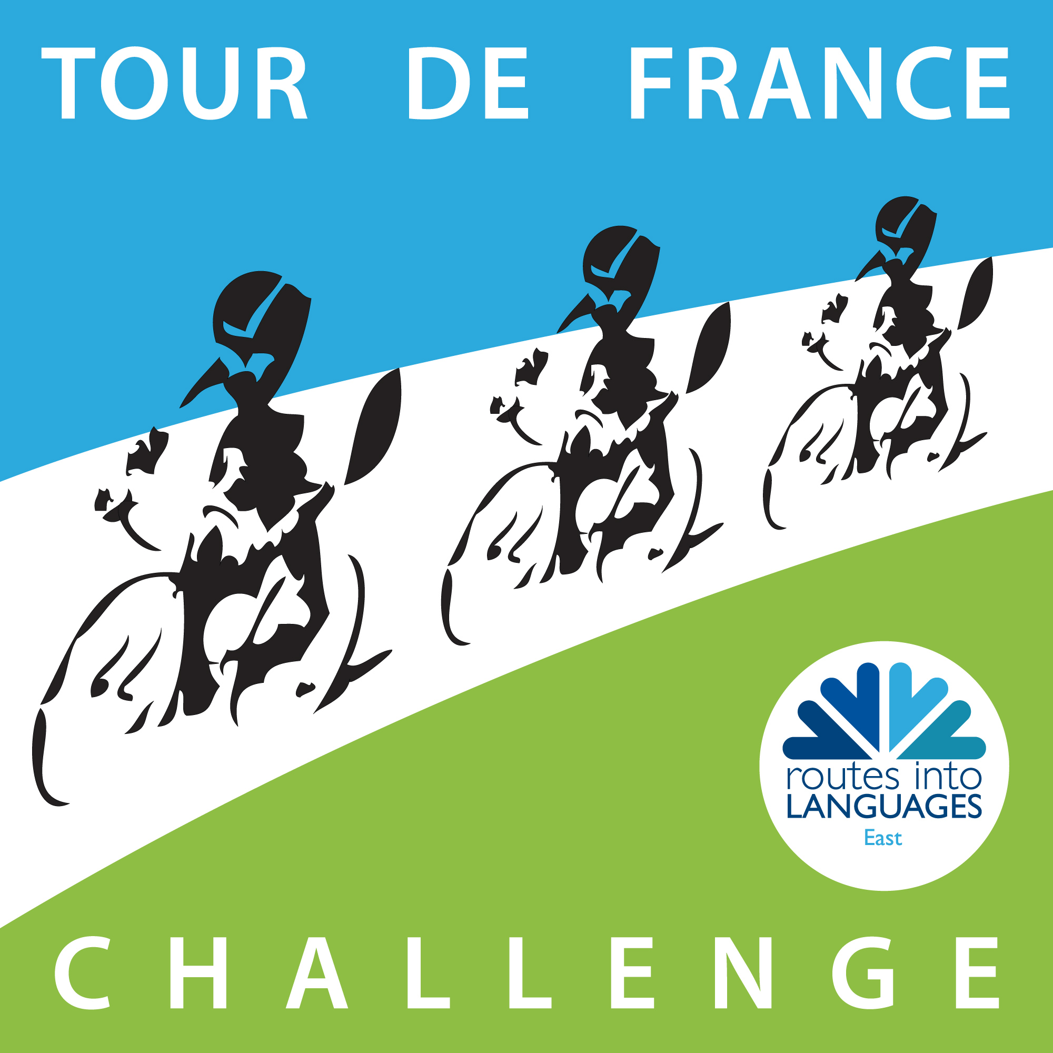 | 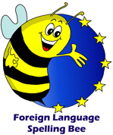

Spelling Bee for the Tour de France Challenge

This challenge is based on the Routes into Languages Spelling Bee competition devised by Jane Driver. The aim is for students to learn, practise and improve their vocabulary, spelling, pronunciation and memory skills in the target language (French, Spanish and German), specifically for Tour de France related vocabulary. For the challenge, students need to select Tour de France related vocabulary to teach to others as well as the alphabet in the target language paying attention to describing letters with accents, etc (see below)
- Students will be given the word in English. In contrast to a monolingual Spelling Bee, they will first have to translate it into the Target Language and then spell it out correctly using the alphabet in the Target Language.
- When participating, students will be given one minute to correctly spell as many words as possible. Students must translate the word with the correct article (this includes l’), but they only need to spell the noun.
- Pronunciation must be accurate and spelling clearly enunciated. If the word and letters are not clearly and accurately pronounced, a point cannot be awarded.
- If they are spelling a colour that begins with ‘de color ……’, they need to say that in the translation, but only need spell the colour.
- They should be allowed to finish a word that they started before the time was up.
- Students can pass at any time, but must say pass in the TL. Accents and other punctuation (note: not question marks) must be spelt in the following way:

  - French
What does the accent look like ? | What is its name ?
â ê î ô û | circumflex accent  accent circonflexe  [siʀkɔ̃flɛks]
ç | cedilla  cédille  [sedij]
é | acute accent  accent aigu  [egy]
è | grave accent  accent grave  [gʀav]
ë ï ö ü | diaeresis  tréma  [tʀema]

    - Space - blanc
    - Pass – je passe
    - Hyphen – trait d’union
    - Apostrophe – apostrophe

  - Spanish
    - Accent – tilde / acento
    - Space – espacio
    - Pass – paso
    - Hyphen – guión

NB New Spanish spelling rules: there is a new name for the letter ‘y’. Previously called ‘y griega’, it is now called ‘ye’. For this year, both will continue to be accepted and this will be reviewed for 2014-15.

  - German
    - Umlaut – Umlaut
    - ß - S-Zett / scharfes S
    - Space – Leerzeichen / Abstand
    - Pass – ich passe
    - Hyphen – Bindestrich

- Hold a competition with words allocated in random order, using the powerpoint template on https://www.routesintolanguages.ac.uk/east/activity/3401
- To use the template, fill in your selection of English words and their target language translations. Then when you run the slide show, the slides will run and can be stopped randomly by clicking the left arrow on your computer keyboard and started again by clicking the right arrow

Holding the Competition
- You should:
  - Compile a list of Tour de France/cycling related vocabulary
  - launch the competition to the students
  - teach the alphabet in the Target Language if necessary ensuring that students can name letters with accents, etc..
  - allocate the words to students so that they can begin memorising them and practising
  - hold a class competition
    - Students should be tested individually and not use any prompts.
    - Students should have one minute to correctly spell as many words as possible in the Target Language.
    - Words should be chosen in random order using the powerpoint template and
    - Words should be given in English, and the student should say the word in the Target Language and then spell it using the Target Language alphabet.
    - Students receive one point per word correctly translated and spelt within the time. If students begin a word when the timer goes, they should be able to finish.
    - In the event of a tie, students with equal scores should participate in an additional one-minute round in which the number of passes should be counted. In the event of a tie in this additional round, the student with the least number of passes will be the winner of the tie-breaker. If they are still tied, a sudden-death round should be played:
      - Students should take it in turns to correctly spell a word.
      - If a student spells a word incorrectly, they are out.
      - This should continue until there is one winner and a runner-up.

