MFL Speaking Competition
Regional Final 2016

Registration Form

Date Wednesday 29th June 2016

Venue Wills Hall, University of Bristol, Parrys Lane, Bristol BS9 1AE

App. Start Time 12 pm

School: ……………………………………………………………………….…………………………

Teacher Responsible: ………………………………………………………………………………...

Participants - Non Native Speaker Category:
Key Stage 3 (please give name(s) of students)

…………………………………………………………………………………………………..

Key Stage 4 (please give name(s) of students)

…………………………………………………………………………………………………..

Key Stage 5 (please give name(s) of students)

…………………………………………………………………………………………………..

Participants – Near Native Speaker Category:
Key Stage 3 (please give name(s) of students)

…………………………………………………………………………………………………..

Key Stage 4 (please give name(s) of students)

…………………………………………………………………………………………………..

Key Stage 5 (please give name(s) of students)

…………………………………………………………………………………………………..

Name(s) of accompanying teacher(s):

………………………………………………………………………………………………………..

Number of spectators: ………………………

We would very grateful if you can submit the completed registration form to I.Holdsworth@bath.ac.uk at your earliest convenience and no later than Friday 27th May.
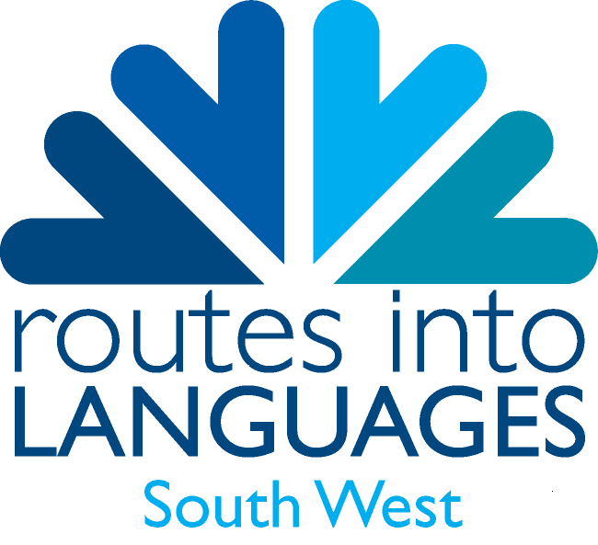
The timings for this event will depend upon the numbers of participating students and will be confirmed once we’ve received completed registration forms from all invited schools.

