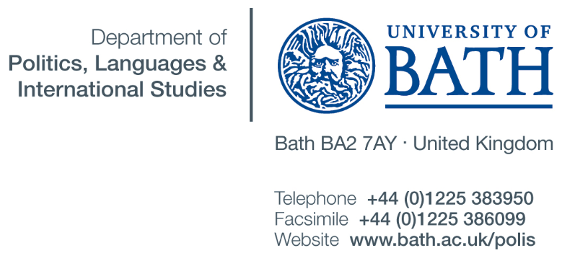
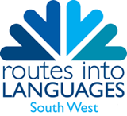

Dear Language Teachers,

We are pleased to invite you and your students to the University of Bath for our annual Language Days in July. We are offering three days for different year groups:

6. July 2016: Year 8
7. July 2016: Year 9
8. July 2016: Year 10

Please find a brief outline of the days (it might change slightly):

Time | Activity
9.30 – 10.00 | Registration
10.00 – 12.00 | Lessons  Spanish, German or French (Post Beginners up to Pre-GCSE)
12.00 – 12.45 | Lunch with Student Ambassadors
13.00 – 13.45 | Language taster sessions, e.g.  Arabic, Mandarin, Italian, Russian,  Japanese (all Complete Beginners)
14.00 – 15.00 | Lecture: Why languages? Feedback session

There will be Student Ambassadors collecting you and your students from the carpark and looking after you for the day. We also provide small snacks and a drink, but please make sure the students bring a packed lunch for the day.

If you and your class are interested, please contact Astrid Forsyth: A.Forsyth@bath.ac.uk for more information or to register (by the 1. June 2016)

Looking forward to hearing from you

Astrid Forsyth

Routes into Languages Coordinator for the University of Bath
German Convenor
Department of Politics, International Studies and Languages
University of Bath

