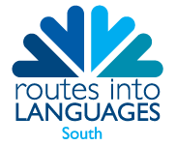
Language Ads Up (University of Sussex) – Registration Form
Please return completed form to languageevents@sussex.ac.uk.
NAME OF SCHOOL: __________________________________ NAME OF LEAD TEACHER: _______________________
This workshop is offered in a number of different languages:
NON-BEGINNERS  French  Italian  Spanish  German  Chinese  Japanese | BEGINNERS  Italian  German  Chinese  Japanese
NB It may be possible to add Arabic and BSL nearer the time. Availability of staff for those TL is unknown at present.
Places offered to schools will be split across the different language groups listed above. We will endeavour to allocate participants their first choice of language group but it may be that we have to go with their second choices.
Please list students’ names and first/second choices in the grid below (up to 20 students per school).
Student Name | 1st Language Group Choice | 2nd Language Group Choice

NB: please note that a cancellation fee of £5 per place booked will be charged if there are any no-shows on the day or if booked places are not cancelled two weeks prior to the event.

