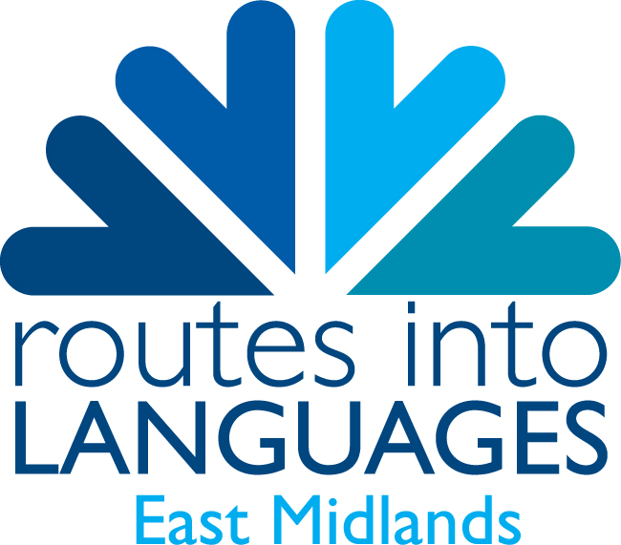
Guide to Languages’ Provision in the East Midlands for Pupils, Parents and Teachers.

Order form

Please fill in the form below to receive your free copies.

I require _____ copies of the pupil/parent guide.

I require _____ copies of the teacher guide.

Delivery details:
Please note: If your school is closed during academic holidays, please supply an alternative delivery address.
Teacher’s name:

School:

Delivery address:

Teacher’s Email Address:
Teacher’s Telephone Number:

What Languages are taught in your school to:
- G.C.S.E? ___________________________________________
- A’ Level? ___________________________________________

Please return this order form by email to:
Email: mirella.santamaria@ntu.ac.uk
Web: www.routesintolanguages.ac.uk/eastmidlands

Thank you for responding. Your order will be dispatched to you shortly.

