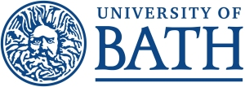
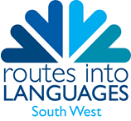
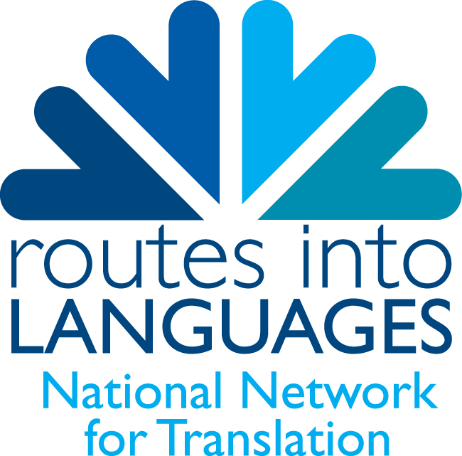
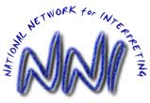

Using Your Languages: Interpreting and Translation
Careers Event at the University of Bath

Looking for a job that will use your valuable language skills?
Open to all sixth-form and undergraduate students.

Venue: East Building, Lecture Theatre EB 1.1
Date: Wednesday 27th January 2016
Time: 14:00-17:30

Registration:
13:30-13:50 Registration: please come to the event venue to sign in on arrival.

Session One
14:00 Welcome
14:15 Dr Svetlana Carsten, Honorary Fellow in Translation Studies, University of Leeds, and ORCIT (EU) Project Leader; Practising interpreter and trainer.
14:35 Dr. Steve Slade, Head of English Translation at the International Court of Justice
14:55 Matthias Postel, The Chartered Institute of Linguists
15:15 Coffee break

Session Two
16:00 Bath alumni
16:15 Q & A with guest speakers and Bath alumni
17:00 Tour of interpreting labs

********************************************************************************
To register for your free place, please email Steven Wonnacott (sw332@bath.ac.uk) with your name and contact details.
Booking Information:
- Registration will take place from 13.30 in East Building foyer.
- Throughout the afternoon, student ambassadors will be on hand to offer directions and answer any questions you might have.
- Please can you inform us if you have a disability so that we can make any necessary arrangements.
Getting Here:
www.bath.ac.uk/about/gettinghere/
http://www.bath.ac.uk/travel-advice/location-maps/index.html

Organised by the South West Regional Consortium (Routes into Languages): https://www.routesintolanguages.ac.uk/southwest, the National Network for Interpreting (www.nationalnetworkforinterpreting.ac.uk) and the National Network for Translation (http://www.nationalnetworkfortranslation.ac.uk)

The Routes into Languages programme is funded by the Higher Education Funding Council for England (HEFCE)
