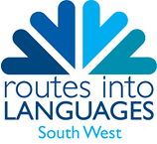
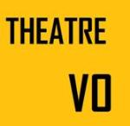
You can learn to run a French theatre club
for your pupils, culminating with
a fun performance for all!

This exciting activity for secondary schools is organised in three stages:

- Training Workshops
for French FLAs/ teachers/ student language ambassadors
DATE: Wednesday 11th November 2015 at the University of Bristol
TIME: 11.00-13.00 for teachers; 14.00-16.30 for assistants
Cost (for attending the workshop): £35 per person

- French Drama Clubs
Clubs will be set up in schools and will run for 4 months – additional advice available via
e-mail/ phone. There may be an opportunity for subsequent meetings.

- Festival Day
DATE: Saturday 12th March 2016 at the University of Bristol
(FREE for participating schools)
● Morning – games/ workshops for participating pupils;
● Rehearsals;
● Afternoon – show (parents/ families/ friends invited);
● Prizes (three main prizes: ‘Best Acting’, ‘Best Language Skills’ & ‘For Creativity’).

The deadline for registrations to attend the training workshop on 11th November is Monday
2nd November. Places will be allocated on a 'first come first served basis'.

Bristol French Drama Festival is supported by Institut Français and will open Semaine de la
Francophonie in March 2016.

For more information or to register please visit our website:
https://www.routesintolanguages.ac.uk/south-west/events/4263

Contact:
Irena Holdsworth
Consortium Project Manager
Routes into Languages South West
I.Holdsworth@bath.ac.uk
https://www.routesintolanguages.ac.uk/southwest/events.html

