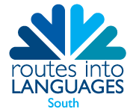
ROUTES SOUTH GREAT LANGUAGES BAKE OFF FINAL
REGISTRATION FORM

Teacher: _______________________________________________________________
School: ________________________________________________________________
Number of entries (max. 2 per school – i.e. up to four finalists): __________________
Total number of students taking part BEFORE school winners chosen: _____________
Language of entry/entries (Fr/Ger/Sp): ______________________________________

NB
Please remember to send in your Bake Off posters to arrive no later than Monday 4th July 2016. The address for entries is:
Clare Forder
School of Humanities
The Checkland Building – Room D331
University of Brighton
Falmer
BN1 9PH

