Routes into Languages
Languages in Action: Employability Week Events

Activity
Universities in the Routes into Languages Capital L London Consortium have put together a range of special thematic days for London school students. Each day will be unique and will focus on different employability-related themes and different community languages. Below is a table that highlights the offered activities:

Date | University | Event theme  (inc. Language Tasters) | Contact
Mon,  7th Jun | School of Oriental and African Studies | Media  (Priority given to speakers/ learners of Turkish or Farsi; language tasters in Indonesian & Japanese) | Mr. Julien Boast  T: 020 7898 4113  E: jv73@soas.ac.uk
Tue,  8th Jun | Kings College London | Health  (Priority given to speakers/ learners of Spanish; language tasters in Turkish & Russian) | Ms. Dominique Borel  T : 020 7848 2381  E : dominique.borel@kcl.ac.uk
Wed,  9th Jun | London School of Economics & Political Science | Business  (Priority given to speakers/ learners of Chinese; language tasters TBC) | Dr. Hong Lu  T: 020 7955 6126  E: H.Lu1@lse.ac.uk
Thu,  10th Jun | University of Westminster | Creative Arts  (Priority given to speakers/ learners of Spanish or Portuguese; language tasters in Arabic & Chinese,) | Ms. Payal Gaglani  T: 020 7911 5765  E: p.gaglani@wmin.ac.uk
Fri,  11th Jun | University of Westminster | Leisure & Tourism  (Priority given to speakers/ learners of Spanish or French; language tasters in Arabic & Chinese) | Ms. Payal Gaglani  T: 020 7911 5765  E: p.gaglani@wmin.ac.uk

Learning Outcomes
The key learning outcomes of the day are as follows:
- to get involved in themed subject-specific activities that show an insight into how languages are used in the real-life working world
- to participate in a range of new language taster sessions
- to interact with staff and students from universities and enjoy the facilities available in higher education institutions
Target Group: Year 9 Students

Numbers: 40 places on first come basis

Date & Time: 7th – 11th June 2010; 10 am to 4 pm

Registration: Please complete the application form overleaf and email it to the contact at the university you would like to attend the event at by Friday, 21st May 2010.
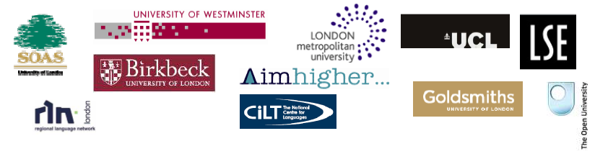

Application Form Overleaf
Routes into Languages
Languages in Action: Employability Week Events

Application Form

Please complete this application form and send it to the key contact at the institution you would like to attend the event at by 21st May 2010.

Title: Full Name:

Address: Postcode:

Contact Number: Mobile:

Email:

Name of School you are currently attending:

Languages you can speak or are currently studying:

Name of the event you would like to attend:

Name of the university:

Do you have any access requirements? Yes No
If yes, please specify:

Do you have any special dietary requirements? Yes No
If yes, please specify:

Please specify if you would like to receive the materials for the course in a particular format. Eg: Large font, CD Rom, etc

Emergency Contact Person:

Emergency Contact Number:

Why do you want to attend the Employability Strand Events? Give 3 reasons.
1.
2.
3.

Name of your language tutor at your school:

Email address of your tutor:

Thank you completing the application form!

