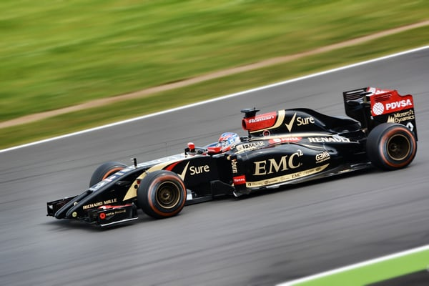

TEN TIPS TO DELIVER A KS3 FORMULA 1 WORKSHOP

1. Start with a group activity – what do we know about the Grand Prix? Flipchart paper and pens to pool ideas would be helpful. You may need to get them started: can you name any drivers? Where do the Grand Prix take place? How many races are there in total? Can you name any sponsors etc? Groups report back.

2. Inform pupils of the outcome / task –to produce a booklet, in French, which the British drivers and F1 staff could use to help them cope in Monaco. Discuss what they might need – eg phrases/vocabulary/cultural information.

3. A group card game with situation headings (eg les directions/faire du shopping/faire du tourisme / au restaurant etc), with words to fit into these categories (eg à gauche/ la crème solaire/ le musée/ un plat principal), would give pupils some ideas for vocabulary to include in their booklet.

4. Some language games to practise this vocabulary and its pronunciation would be helpful here – eg guess which word I’m thinking of/ hangman etc.

5. Provide, or elicit from pupils, some phrases which could be useful to the drivers eg où est …..? / je peux réserver …? etc.

6. Pin around the room some phrases which incorporate phrases from 4. and vocabulary from 3. eg où est le musée, svp? Those finishing quickly can make up some of their own.

7. When pupils begin the group project to produce the booklet, computer access may be useful eg to find some French facts (weather in Monaco? Popular French food?) The availability of dictionaries would also encourage them to include new material.

8. They will need a sponsor to pay for the production of their booklet – they could research some French companies who could sponsor them – eg EDF, Michelin, Mumm etc). If computers are not available, some handouts around the room with French companies and their logos and brief information on the companies, would be helpful for pupils to view. Pupils could aim to copy the logo if they are not able to print it out, or design a new one of their own.

9. Give a time limit – maybe 50 minutes- to produce the booklet. Each group should then give a presentation, saying what they have included in their work, and stating why their booklet should be chosen to be used by the British team. They should also explain why they chose their sponsor. This can be completed with a mixture of French and/or English, depending on the ability of the group.

10. A prize for the winning group would be an incentive, perhaps!

Cheryll Shuttleworth

