French, Drama and a Feather Duster on Stage in Bristol
By Irena Holdsworth
Can there be a more complicated task than to ask secondary school students to create a short play in French on the topic ‘feather duster’ and then perform it on stage in front of a large audience consisting of school teachers, parents, peers, university academics and representatives from the French Embassy? Maybe not, but this exercise proved to be a piece of cake for students in the South West!
Bristol French Drama Festival – an exciting and creative project for secondary schools in the South West – is organised by Routes into Languages SW in partnership with Audrey Johnson and Emilie Poletto, two enthusiastic and experienced drama teachers from a Bristol-based company, Theatre VO. The festival, held for the second year and supported by Institut Français and Alliance Française, opened the International Week of French Language and Francophonie 2014 on Saturday 15th March at the School of Modern Languages, University of Bristol.
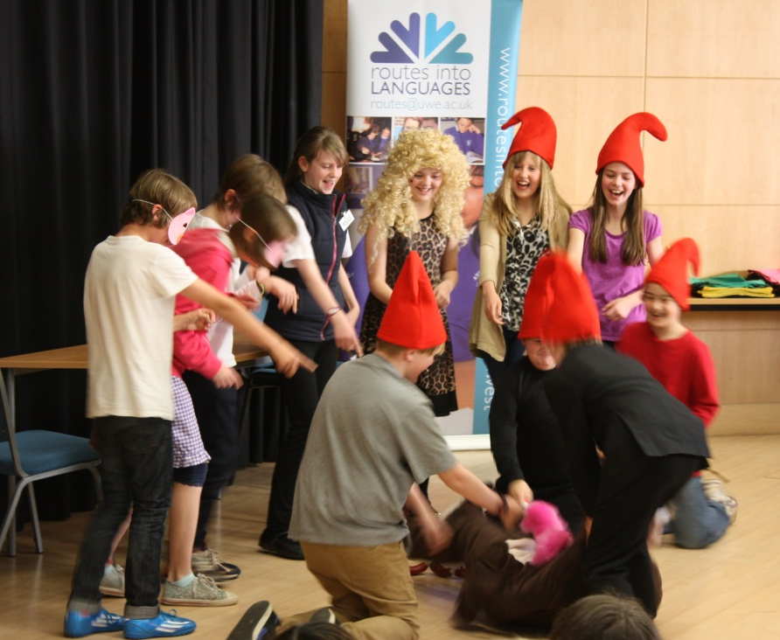
Forty students from Year 7 to Sixth Form performed their inspiring and humorous plays on stage. It was a triumphant culmination of students’ enthusiasm as well as hard work and commitment, which are essential to successful implementation of this project.

The project takes place over several months. Interactive training workshops, ‘Teaching French through Drama’, are organised for French-speaking foreign language assistants, teachers and student ambassadors in the autumn to give them the confidence and numerous ideas on how to develop and run a French theatre club in school. They then go back to their schools with the aim to organise a French drama club for students who are interested in both subjects (French and drama) to run weekly during the lunch break or after school.
They have just over four months to put their experience and useful tips and ideas into practice and enthuse students to create a 5-10 minute performance on the pre-determined theme – this year it’s ‘feather duster’. The challenging but rewarding exercise unlocks imagination, brings talent to light and offers teenagers a different and attractive perspective to learning foreign languages.
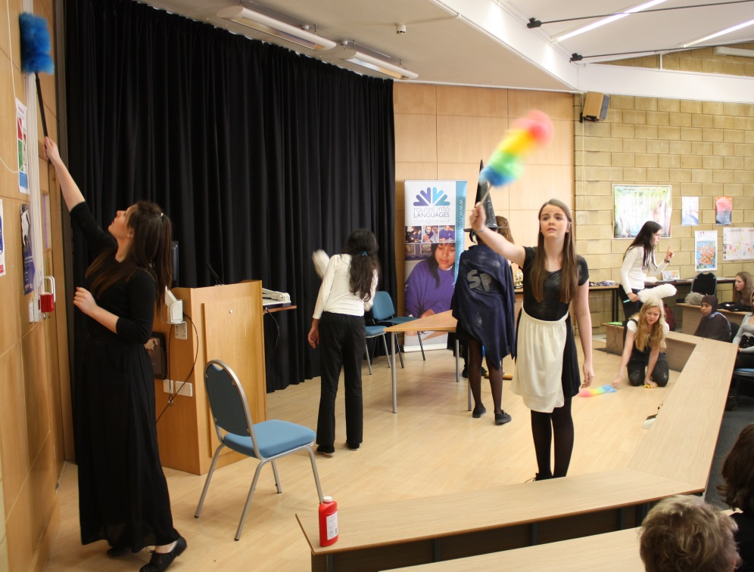
The morning of the festival day is full of fun-packed activities and warm-up games for performers and includes time for each club to rehearse their production on the festival stage before the final show. The afternoon show offers an exciting and breath-taking experience for participants and a great opportunity to showcase their talents and, of course, show off their language skills.
This year the final show opened with a guest performance by an adult French drama club from ‘Hen & Chicken’ led by Audrey Johnson – which was organised as a special surprise for the participants. The prop for their play was an adult version of a feather duster – ‘vacuum cleaner’
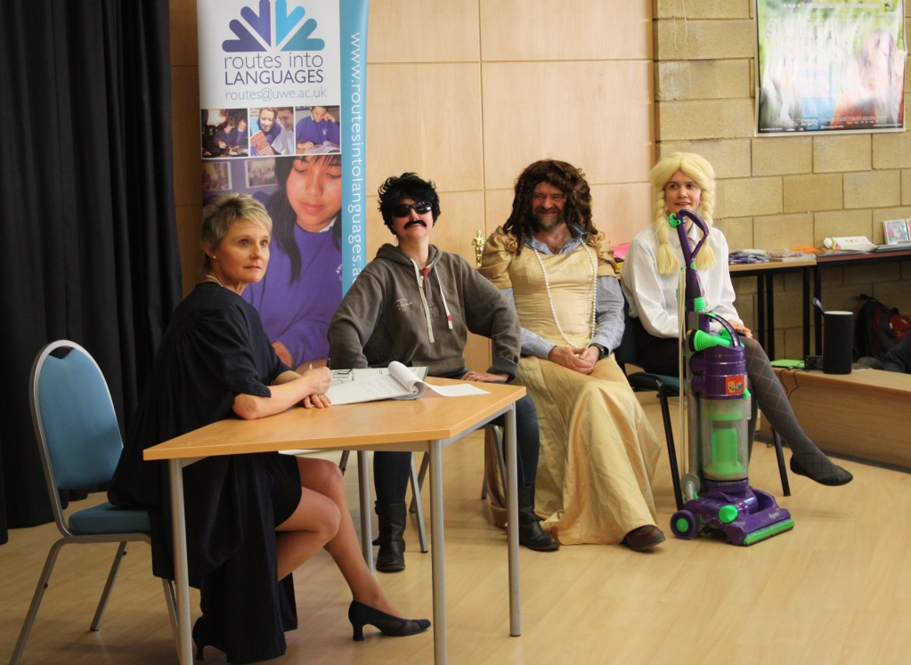
Three prizes were awarded to participating schools at the end of the day – for Best Acting, Best Language Skills and Creativity.

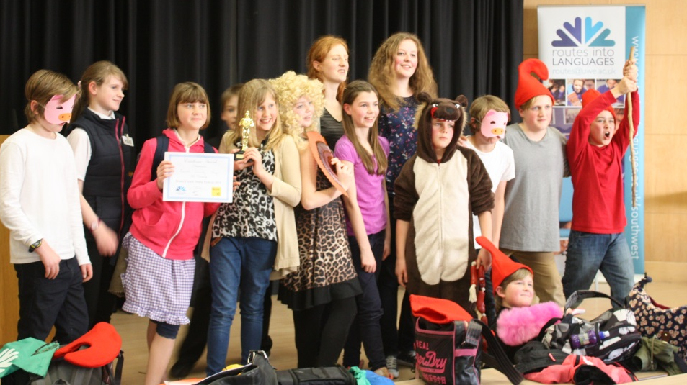
All the festival performances can be watched on our RiL South West YouTube Channel: http://www.youtube.com/playlist?list=PL1BjxG4T6BPj70wMqlnlaq_p3w2sump-X

