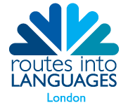
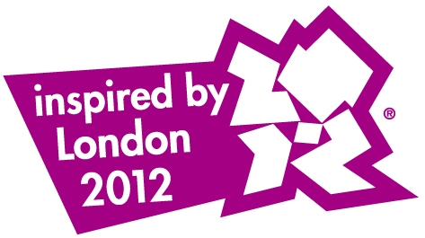

The L Factor Song Competition

Do you think you could write a song or rap in a foreign language? Do you have the IT/Media skills to make a video to accompany your song? If so… this competition is for you.

Capital L, the London consortium of Routes into Languages is inviting you to submit a short video, animated if you prefer, to accompany a song or rap which you have composed in a foreign language. Short-listed entries will be invited to perform at the London Final in June 2012, to coincide with the London 2012 Festival.

The theme of the competition is Friendship, one of the Olympic values.

We welcome entries in any language.

Rules of the competition

- The competition is open to any student or group of students in full time education between the ages of 14-19 in two age categories: 14-16 & 17-19 y.o.

- The video produced should be no longer than 2 minutes.

- The theme of the competition is: Friendship. Friendship between peoples and between individuals as those fostered by the Olympic Games.

- The video must be a new work shot in 2011-12.

- NO COPYRIGHT MUSIC OR VIDEO CAN BE USED. All parties agree to allow the film to be mounted on the website and/or YouTube Capital L page.

- The material has to be submitted as a digital video in either QuickTime or MPEG movie format on CD or DVD.

- All entries must be submitted by 30 March 2012. Entries should be sent to Capital L Project Manager, School of Oriental and African Studies (SOAS), Thornhaugh Street, Russell Square, London WC1H 0XG

- All entries must be accompanied by a complete registration form available from www.routesintolanguages.ac.uk/london and a translation of the song lyrics into English.

- The videos will be judged by an independent panel and their decision is final.
For details of how to submit entries and the rules of the competition, contact your language teacher. Selected entries will be announced on 18 April 2012.
For this competition, London has been divided into four regions: North, South, East and West. Each region will then refer the top 3 entries in each age category for the London final, totalling 24 songs.

The others are: excellence, friendship and respect. The Paralympic values are courage, determination, inspiration and equality.

