Language Immersion Challenge

- This programme is open to all students from years 7 to 13
- Participants will be awarded Gold, Silver or Bronze certificates, depending on the number of challenges they complete (plus, a brand new advanced challenge to receive a Platinum Certificate for years 10 - 13)

- Bronze Certificate = 4 challenges completed
- Silver Certificate = 8 challenges completed
- Gold Certificate = 12 or more challenges completed
- Platinum Certificate = For years 10 - 13: Completed Gold Certificate + the Advanced Challenges

- This booklet is to be used to keep a record of the challenges completed.
- Booklets must be returned to your MFL teacher in September. Following this, certificates will be awarded.
- Some activities this year involve using social media - please make sure to always be careful online and don’t talk to people you do not know! If you are worried about yourself or a friend with online use, tell a teacher or parent.

Name:
Target Language (TL) chosen:
- Listen to the radio in the TL for 5 minutes 5 days a week for 4 consecutive weeks. Keep a radio diary (below) with detailed notes at least once during each week. There are several radio stations that stream online and there are iPhone apps and channels that can also be found on digital radios.

Week Commencing: | Radio Channel(s) Listened to: | Notes:

- Find a song in the TL country charts that you like.

Song title:
Artist:
Why do you like it?
Can you translate the chorus into English?

- Go for a walk; find 5 objects/things and note them down (e.g lamppost, letterbox, plant pot). When you get home, find the translations of what you found in your TL without using the internet!

1.
2.
3.
4.
5.

Since we are all stuck at home and probably won’t be sending postcards from holidays, write an email to tell your MFL teacher what you’ve been doing at home to keep busy - in the Target Language of course!

- Email your teacher!

Date sent:
To: (insert teacher’s name)
Copy and paste your email message here:
- Find a recipe online of a dish from your TL’s country and try it out (following the instructions in the TL if you can!).

Recipe Title:
Level of Difficulty:
Result—your opinion:
Result—someone else’s opinion:

- Watch a film in the TL. There are foreign language films on YouTube, Netflix and various other foreign language channels on the Internet.
Complete the notes below

Title:

Brief summary of what the show is about:

Who was your favourite character?

Did you like the film? Why?

How well did you understand it? (circle the appropriate symbol)

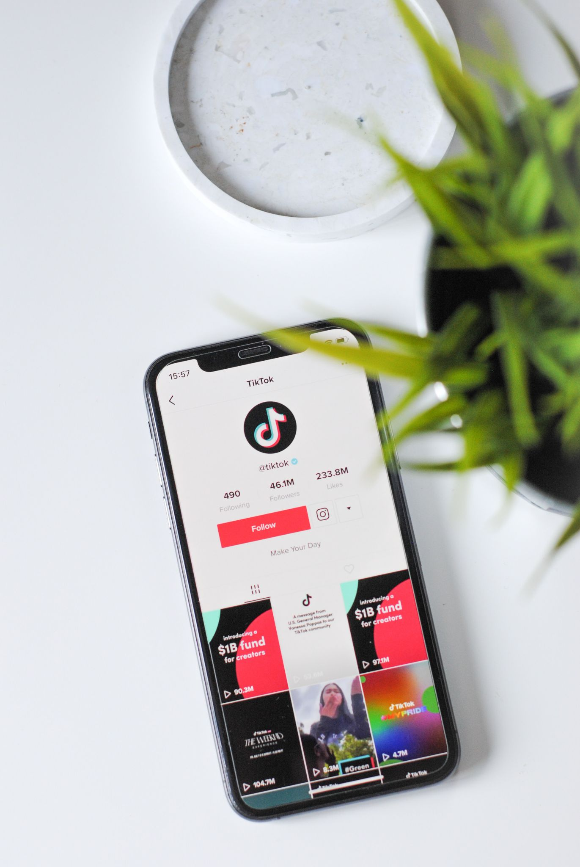
7. Watch 5 language based TikToks (or Reels on Instagram!). Describe what happens in each and then draft an idea of a language TikTok you would make, including filters, transitions and sound!

TikTok/Insta Handle: | Video Description:
@
@
@
@
@

My TikTok Idea:

8. Follow 5 language teaching accounts on social media (Instagram will be best for this). Spend a few minutes a day on each account, and save/like the posts to make them more accessible in the future!
Note down some of the language lessons you’ve learned from the accounts below (e.g if an account you follow taught you a new phrase in your TL, add it to the table!).

Social Media Handle | Language Lesson Learnt
e.g @yourdailyspanish (insta) | Phrase: Estoy entre dos aguas - I'm undecided
e.g @tumulearning (insta) | French Expression: Rapide vs Vite
e.g @pourquoipasfrench (insta) | Grammar: Tenses you need to know in French
@
@
@
@
@
@
@
@
@
@
@
@
@
@
@
@
@
@

(Add more below if you need to!)

9. Find a newspaper in the TL online.

Name a headline:
What does it mean?
Give an overview of the article:
Find two more news resources in your TL and add them here:
10. Send a text message to a friend in the TL - try to make sure it’s at least 10 words long!

Re-write the message here:

Did they understand you? Yes/No

Did they reply in the TL? Yes/No

If Yes, what was their reply?

11. Find out the nationalities of either:
- Players in your favourite sports team OR
- Actors in your favourite TV show/film
If you have time, you can even try to find out if they speak any other languages! There are lots of bilingual and multilingual celebrities!

Player/Actor: | Nationality: | Languages spoken:
12. Create a cartoon with speech in the TL.

13. Post a question on your Instagram story that asks your friends: ‘I am learning (insert TL). Do you speak/learn this language too?’. You may be surprised how many of your friends are learning the same language as you! Keep in touch to practise your language skills together.

Record your responses here (you can post more than once if you have more that one TL):

My Target Language | Number of Responses
e.g Spanish | 15

14. Write out the household weekly shopping list in the TL. Go online or to the supermarket with your parents/guardian and order/shop for your weekly groceries with them. Translate the list for them as you go.

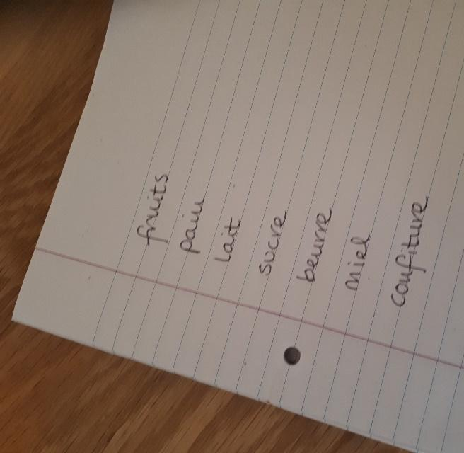

Date:
Did you remember what everything was? | Yes / No
Which ones did you struggle with? Write them here to help you remember in the future!

PLATINUM - ADVANCED LEVELS
Certificates available for students in Year 10 and above

Advanced 1. Look back at the text you sent your friend in activity 10 - now research how to text-type in your TL and change the text to shorthand.
Example:
Original text (TL = Spanish): | Hola. ¿Qué tal? ¿Por qué no está en clase? Te quiero mucho, besos.
Shorthand text: | hla. q tl? xq no ta en kls? tqm, bs.

Have a go!
Original text:
Shorthand text:

Advanced 2. Change your mobile phone and/or social media language settings to your TL for 4 weeks.

Start Date:
End Date:

After the 4 weeks, write below about your experience:
Did you learn new vocabulary?

Was there anything in particular that you struggled with?

Will you keep your language settings in your TL from now on?

Advanced 3. Play the Post-It note game! Write down language questions on Post-It notes, such as ‘conjugate this verb’ or ‘translate this word/sentence’. Then, stick them around your room and house on things such as cupboards, the fridge, the biscuit tin and so on… you can’t open the door until you answer the question!
Give some examples of questions you used during the challenge:

Question: | Solution:

Advanced 4. Construct 5 subjunctive sentence structures in your TL that can be used in many contexts. This will be great preparation for those going into A level, as you will get used to using the subjunctive more naturally!

Target Language | Subjunctive Sentence | English Translation
e.g Spanish | e.g Espero que puedas... | e.g I hope that you can...

Advanced 5. Choose a friend, classmate or family member who speaks/is learning your target language. Set a goal to speak only in the TL for a full day. If you come across words you don’t know, use a dictionary to translate and then note them down for the future!

Date | New word (TL) | New word (English)

Congratulations!

You have completed the Language Immersion Challenge!

Follow us on social media for more language resources:

