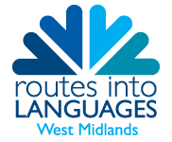
Year 13 Languages Online Event

Wednesday 16 December 2020, 13.00 – 14.30
12.30 – 13.00 | Registration
13.00 – 13.05 | Welcome | Dr Raquel Fernández Sánchez, Director, Routes into Languages West Midlands  Claire Richards, Project Manager, Routes into Languages West Midlands?
13.05 – 13.15 | Languages in HE | TBC
13.15 – 13.55 | LECTURE CHOICES  French-  Spanish - | Dr Emmanuelle Labeau, Aston University  Dr Stephen Fay, Aston University
14.05 – 14.30 | Ambassador Panel and Q&A | Routes into Languages Ambassadors who are in the final year of their degree at Aston University  Gemma, Bsc French & Spanish  Michela, Bsc English Literature & French
14.30 | Close

