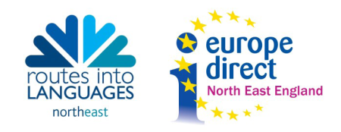
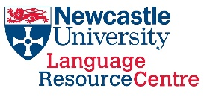

Joining Instructions: Beat the Rat Race 2017
Wednesday 13th December 2017
09:30 – 14:30
The Beehive, Old Library Building, Newcastle University, NE1 7RU

Map: please see separate document or visit http://www.ncl.ac.uk/about/visit/maps.htm. The Beehive is in the Old Library Building No. 25 on the Campus Map.

- Attendance and cancellation policy
This event is free to all guests. However, a cancellation fee of £50.00 will be charged to any cancellations made within 1 week of the event.

- Key Information
Pupils must be accompanied by a teacher to the event and must not be left unsupervised at any time during the day. Our Student Ambassadors have not undergone DBS checks at this current time. A full list of pupil and teacher names and other details as requested must be emailed to helen.kenny@ncl.ac.uk no later than Wednesday 29th November.

- Arrivals
Registration will be from 09:30 – 09:55 at the Beehive registration desk which will be clearly signposted. Please arrive punctually for a 10:00 start.

- Transport
  - Drop-off: there is a drop-off point for buses on King’s Road outside the Hatton Gallery. If you enter from the Claremont Road entrance you can drop-off and walk the short distance to the venue.
  - Parking: we regret that there is no parking available for buses of any kind on the university campus. Bus drivers must make their own arrangements for parking their vehicle during the event.
  - Public Transport: Newcastle University is easily accessible by bus, train and Metro. The nearest Metro station is Haymarket, a short walk from the venue.

- Programme
Please see the accompanying document for a full programme for the day. Please note that this may be subject to minor change.

- What to bring
Please ensure that you and your pupils bring along with you:
- The pre-delivered activity booklets, having completed the relevant sections in advance
- Completed pre-event pupil questionnaires for all pupils
- Lunch
A buffet lunch will be provided for teachers and pupils will be given a packed lunch free of charge, to be eaten in the Beehive. Please ensure that any dietary requirements are listed as part of the information provided in addition to teacher and pupils names.

- Language Taster Sessions
School groups will be allocated to language taster sessions in advance, taking into account the language(s) already studied according to information provided in advance by the school.

- Contact
If you have any further questions about the day, please email Language Learning Support Officer Helen Kenny (helen.kenny@ncl.ac.uk) or phone the Routes into Languages North East office on 0191 208 5454. For emergency contact on the day, please phone the Language Resource Centre reception on 0191 208 7490.

