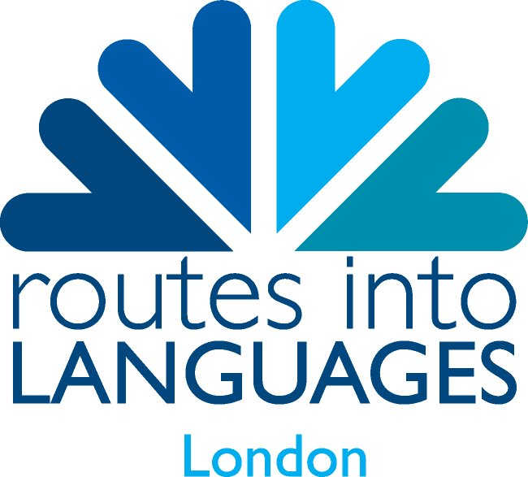
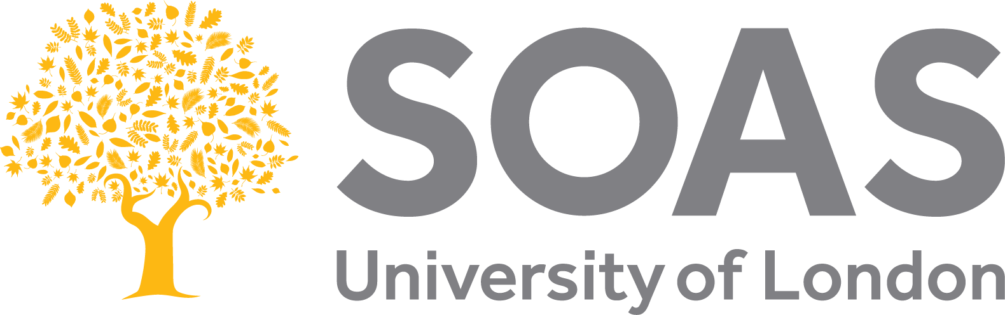

School of Oriental and African Studies
University of London

APPLICATION FORM
Capital L / SOAS World Languages Immersion Programme for URDU speakers
Wednesday 5th July – Friday 7th July 2017

STUDENT DETAILS (Please print clearly)

Full Name ……………………………………………………………………………………………………………..

Date of Birth………………………………………… Male / Female

School …………………………………………………………………………..………………………………………..

Please indicate which year group you are in (please tick):

Year 9 Year 10

Mobile Number…………………………………………..email……………………………………………………….

Home address…………………………………………………………………………………………………………….

……………………………………………………………………………………………………………………………………

Subjects currently studied ……………………………………………………………………………………………..

…………………………………………………………………………………………………………………………………….

How long have you been speaking Urdu? ……………………………………………………………….

Would you be the first in your family to go to university? Yes / No

Are you or have you been eligible for Free School Meals? Yes / No

SCHOOL AGREEMENT

Signature of supporting teacher………………………………..……….. Date…………………………….

Teacher name (printed) …………………………………………………………………………………………..

Phone number……………………………………………………..email………………………….…………………
PLEASE TURN OVER

PARENT / GUARDIAN AGREEMENT

I have read the information sent and agree to the student named above attending the Urdu Immersion Programme. I understand that I am responsible for them travelling to and from the Urdu Immersion Programme.

Signed…………………………………………………………………………Date………………………………………..

Name (printed)……………………………………………………………………………………………………………

EMERGENCY CONTACT DETAILS ( DAYTIME )

Contact Name……………………………………………..Phone number………………………………………….

Relationship to student……………………………………………………………….

The UK Data Protection Act (1998) requires us to obtain your explicit consent to process and retain your son/daughter's data. We will process this data in accordance with these principles. We will not give your details to third parties except where necessary for the fulfilment of this application. We will NOT USE the data provided in this form for marketing purposes.

Please tick this box to confirm that you give consent to the above use of this data. 

PHOTOGRAPH AND VIDEO CONSENT

We may wish to take photographs and video footage of participants and their work during this Urdu Immersion Programme. These may appear in our printed publications and/or on our websites. Also third party media may be invited to take photographs of the activities.
Before using any of these we need the permission of the individual’s parent / guardian. No name or personal details will be published alongside any images unless your specific permission has been granted.
Please complete the statements below by circling the appropriate answer.

Student
I consent to photos and video footage of me, the participant, taken during the Urdu Immersion Programme,
- To be used on printed publications surrounding the course. Y N
- To be displayed on organisers’ websites. Y N

Signed …………………………………………………………………………………………………………………

Parent / Guardian
I understand the information given above and confirm it is correct.

Signed……………………………………………………………………………..…Date…………………………………

