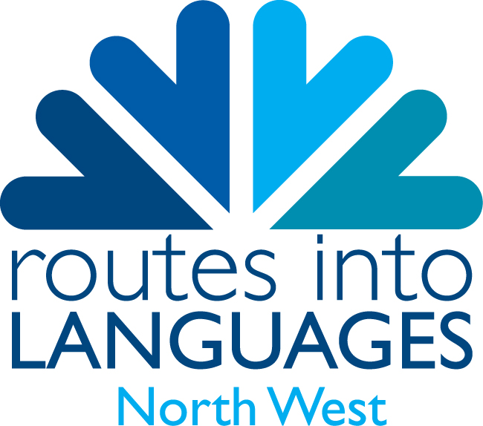

ADOPT A CLASS
REGISTRATION FORM

◻ I would like to register to be a part of the ‘Adopt a Class’ scheme

Name:

School:

School address:

Contact telephone number:

Contact email address:

Please indicate with which language you would like to be linked

French ◻

Spanish ◻

German ◻

Italian ◻

I understand the school will make a contribution of £200, if our application is accepted.

Signed: _______________________________________ Date: _______________________

