Stationery item | 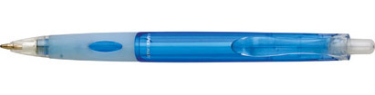  Image | Costing
Pen | 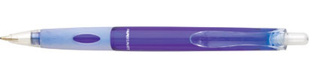 | available in  ◻ light blue with silver logo & URL  ◻ royal blue with silver logo & URL  ◻ 50:50 of the above  ◻ 1000 @ 45p each  ◻ 2500 @ 43p each  ◻ 5000 @ 41p each  Plus VAT and £35 delivery
A4 Poster paper |  | ◻ 1000 = £136.00  ◻ 2000 = £171.00  ◻ 5000 = £230.00  Plus VAT
Compliment slips | 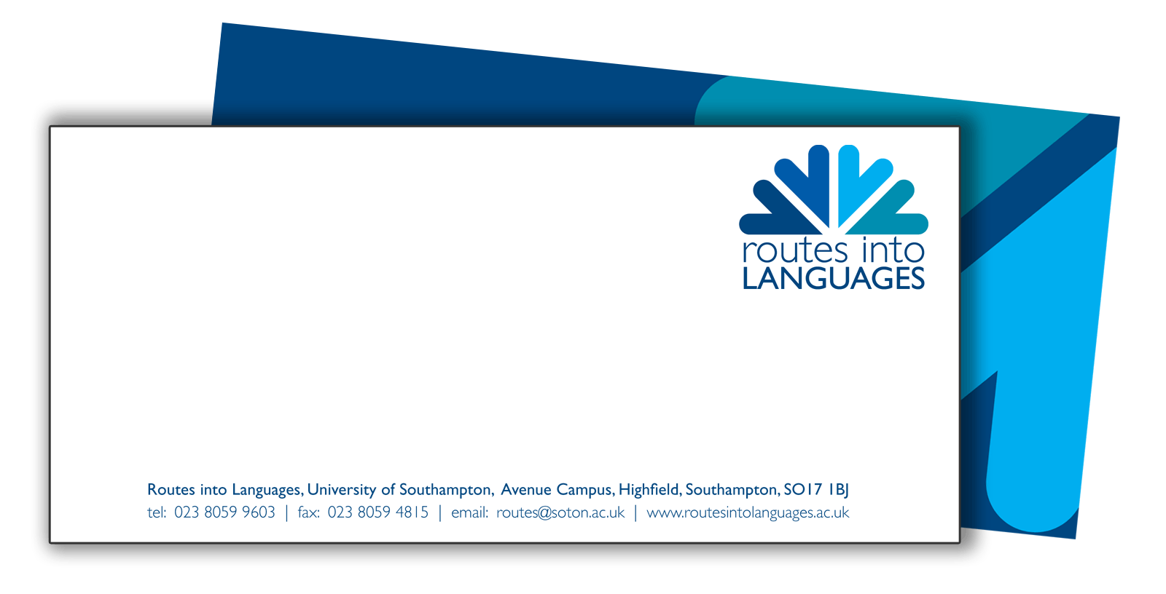 | ◻ Stationery deal – 500 of each item for £258.70  Plus VAT  Or individually:  ◻ 500 comp slips £102.70  ◻ 500 business cards £65  ◻ 500 headed paper £128.70  Plus VAT
Business cards | 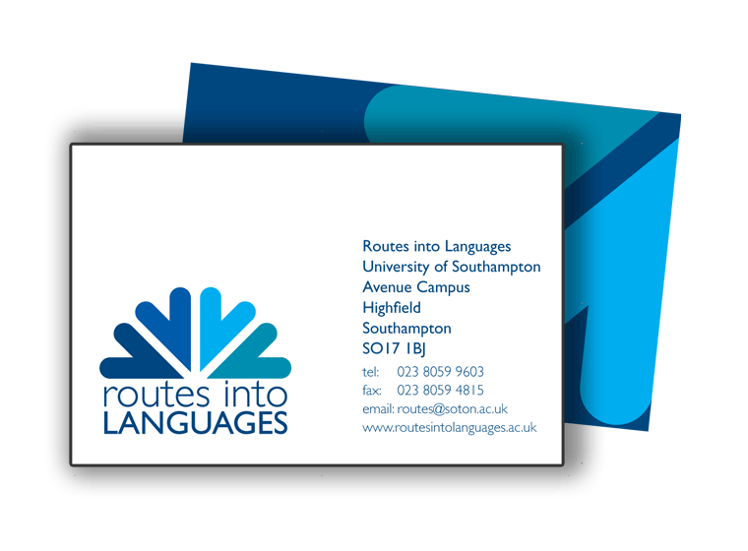
Headed paper | 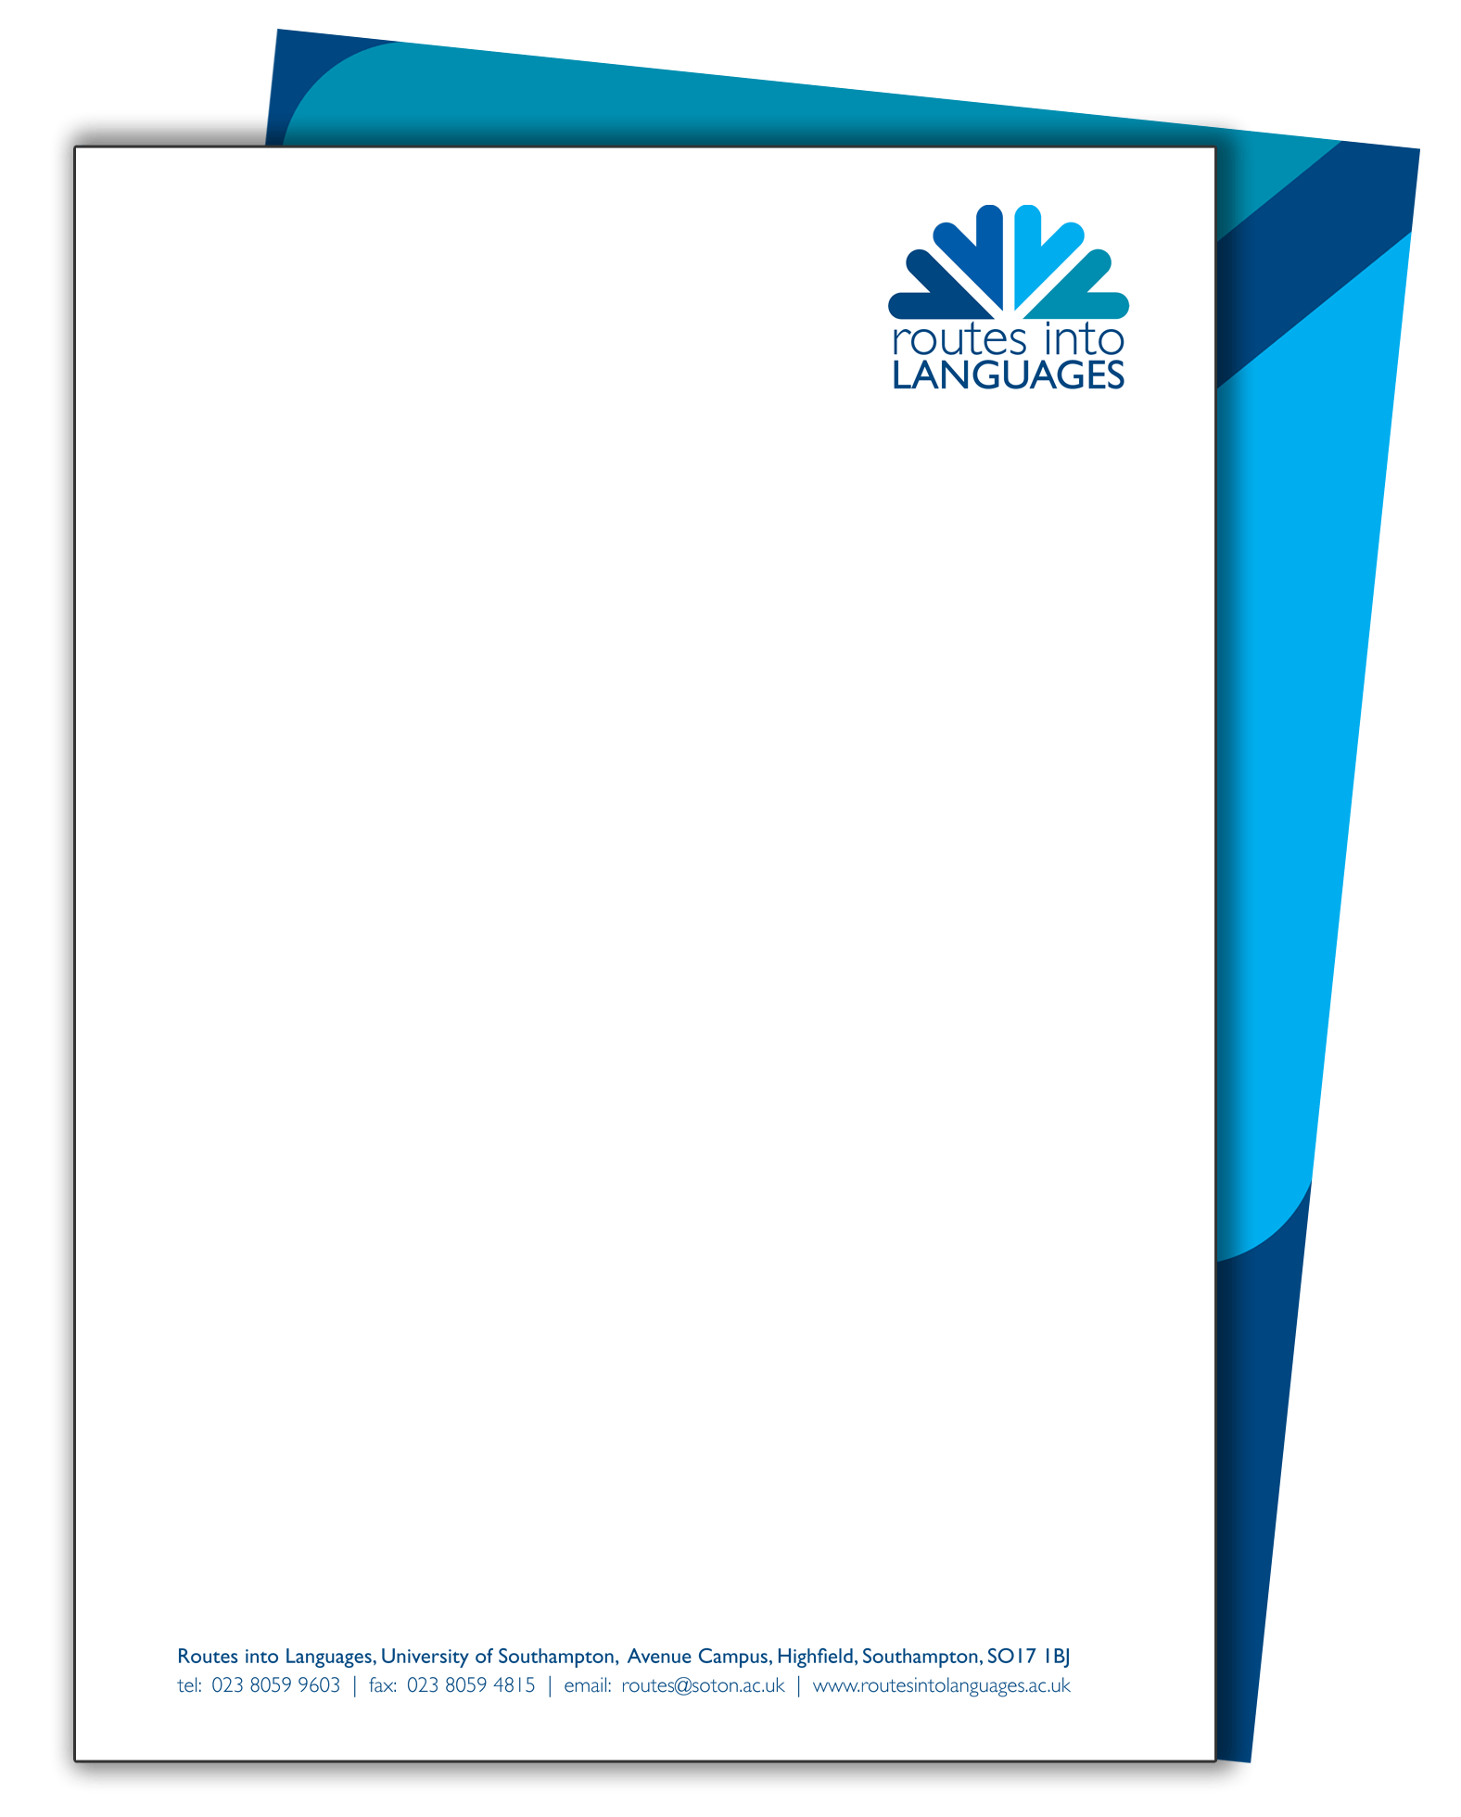
Mailing list postcards | 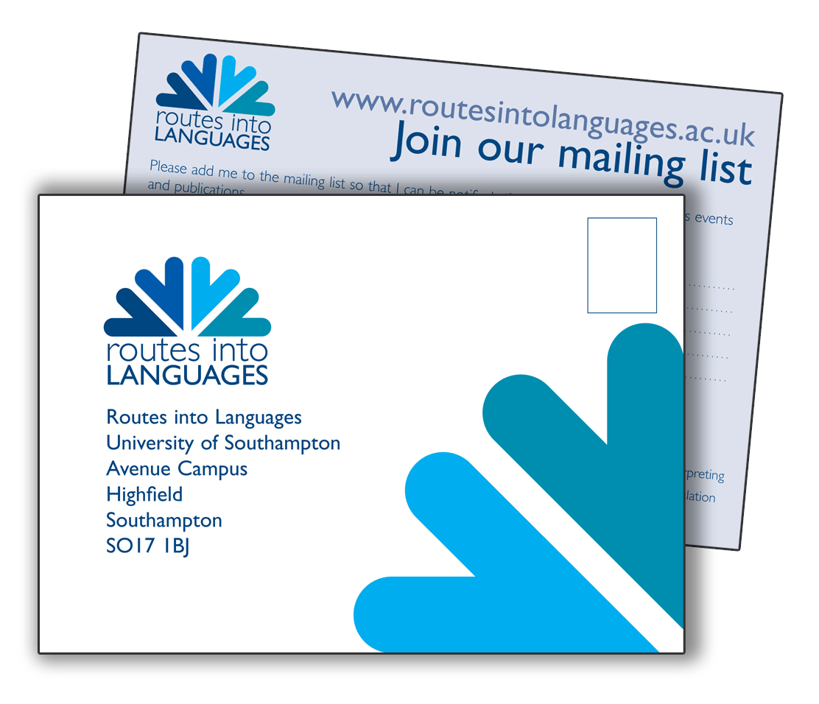 | ◻ Free of charge  How many? ______
Key Facts for teachers |  | ◻ 500 leaflets £175.00  ◻ 1000 leaflets £187.00  ◻ 1500 leaflets £198.00  Plus VAT

If ordering the stationery deal

- Address incl postcode of the institution as you wish it to appear on the business card/compliment slip/headed paper:

- The email address/telephone number/fax number as you wish to appear on the business card/compliment slip/headed paper
(most institutions are adopting the routes@institution.ac.uk approach):

- The title, first name, surname and email address of the consortium director and project manager as you wish it to appear on the business card

***********************************************************************************************************************************************************
For all orders

Region:

Name and email address of the person initiating the order:

The address to which you would like the items and the invoice sent:

Total amount ordered: £_____

