Merchandise from the Regional Consortia
COTTON BAGS  Cost per 1000:  Approximately £2060.00  Which Regional Consortia ordered these initially?  Routes into Languages East  Contact:  Sarah Schechter | 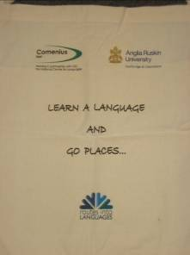  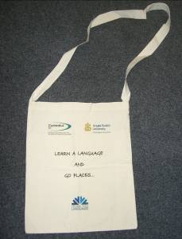
MEMORY STICKS  Cost per 1000:  Approximately £4110  Which Regional Consortia ordered these originally?  Routes into Languages East  Contact:  Sarah Schechter | 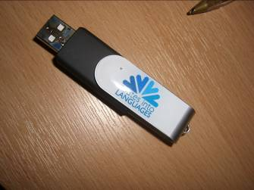
MUGS  Cost per 1000:  Approximately £3000  Which Regional Consortia ordered these originally?  Routes into Languages NW  Contact:  Ameeta Chadha | 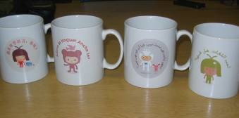  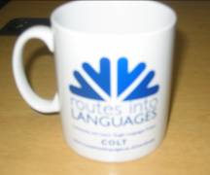
DRAWSTRING BAGS  Cost per 1000:  £836.60  Which Regional Consortia ordered these originally?  Routes into Languages South  Contact:  Clare Forder | 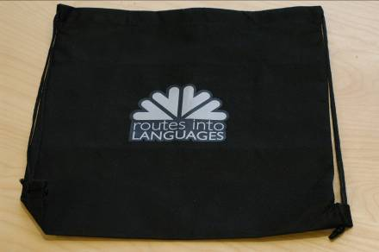
PUZZLES  Cost per 1000:  £552.25  Which Regional Consortia ordered these originally?  Routes into Languages South  Contact:  Clare Forder | 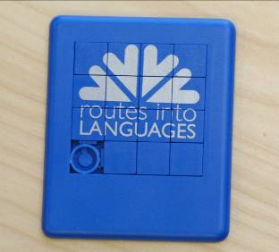
BOOKMARKS  Cost per 1000:  Approximately £179  Which Regional Consortia ordered these originally?  Routes into Languages NW  Contact:  Ameeta Chadha | 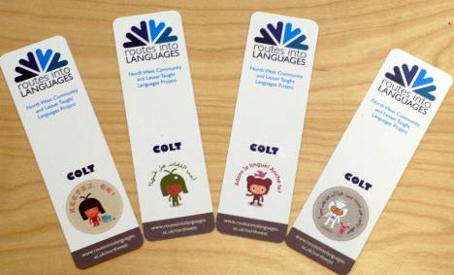
OYSTER CARD HOLDERS  Cost per 1000:  Approximately £860 + £15 delivery  Which Regional Consortia ordered these originally?  Routes into Languages London  Contact:  Renata Albuquerque | 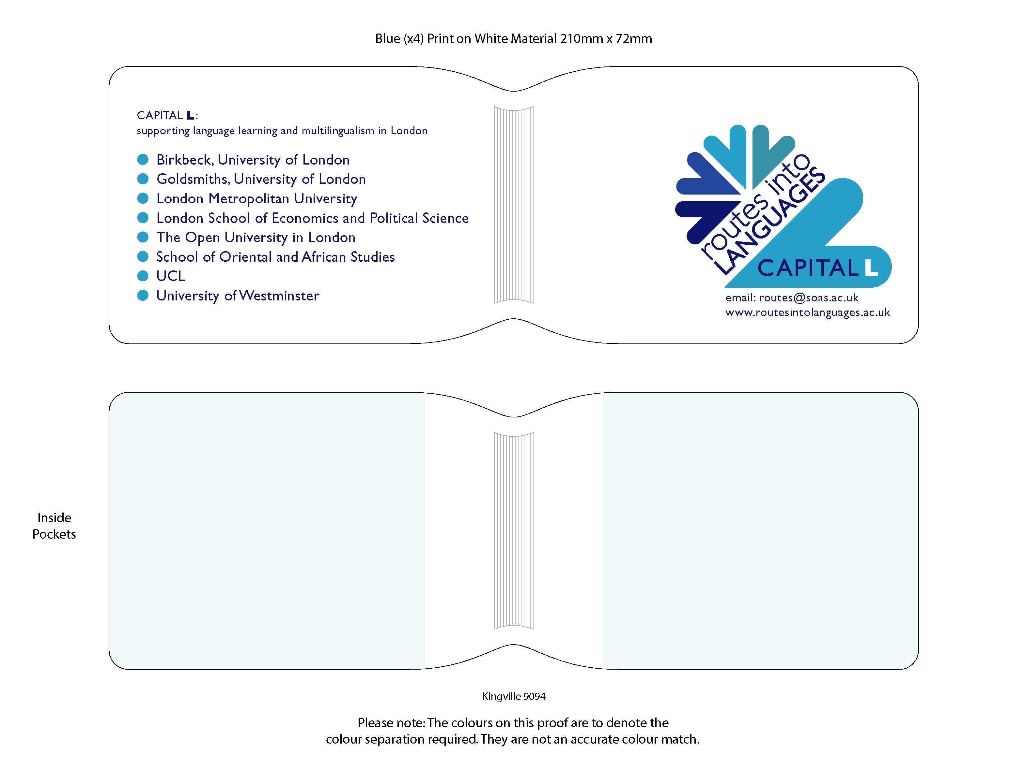
MEMORY STICKS  Cost per 1000:  Approximately £4420  Which Regional Consortia ordered these originally?  Routes into Languages West Midlands  Contact:  Kat Stevenson | 