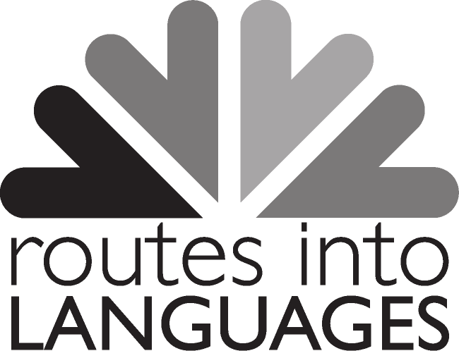
Routes into Languages International Student Ambassadors
Case Studies

TEMPLATE 2 (for ambassadors coming to the end of their role)

We would like to know more about your experiences as a student ambassador as this helps us to evaluate the Routes into Languages programme. We would be grateful if you could complete this form. The information that you provide will be kept confidential.
Please tick to show that you agree to us using your opinions for evaluation purposes □

Name (optional):

Male/female (please circle)

Name of university:

Year of study:

Which languages do you speak?

In which country did you attend school?

Why did you choose to become a student ambassador?

Describe the activities you have been involved in as a Routes student ambassador

What do you feel were the positive benefits for the school/college pupils that you were working with?

What do you feel you have learnt in your role as a student ambassador?

What are your plans for when you finish your degree?

How do you think your work as a student ambassador will help you with your future plans?

Thank you for completing this questionnaire

