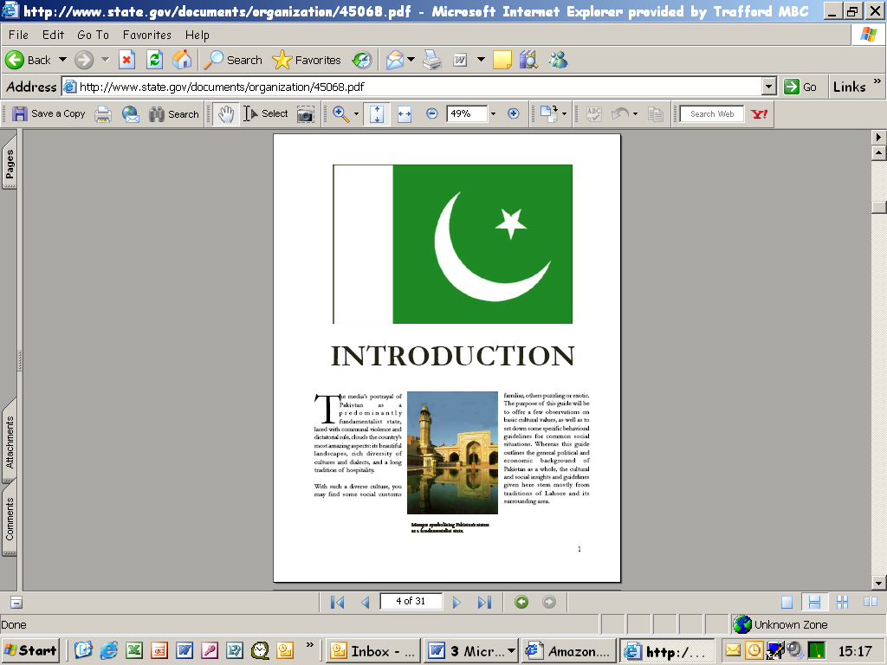

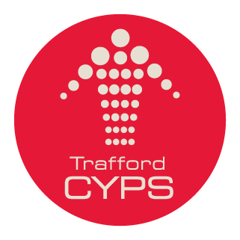

Urdu Primary language and methodology course for teachers of young learners

Where and when:  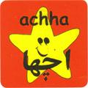 | Manchester Metropolitan University, Didsbury Campus  Complete course  April 28th 9.00 to 4.00 full day  April 29th 4.00 to 6.15 twilight  May 6th 4.00 to 6.15 twilight  May 13th 4.00 to 6.15 twilight  May 20th 4.00 to 6.15 twilight  June 10th 4.00 to 6.15 twilight  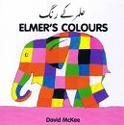  June 17th 4.00 to 6.15 twilight  June 24th 4.00 to 6.15 twilight  July 1st 4.00 to 6.15 twilight  July 8th 9.00 to 4.00 full day
Course content: | The teaching of the Urdu language through Primary/Young Learner methodology  Access to many teaching materials, games, websites etc
Aims and objectives: | To bring life to the teaching of Urdu through highly interactive methodology for the language and culture  To teach beginners Urdu for this, and native speakers the methodology required for high quality teaching of this language
Who should attend: | Those interested in teaching Urdu, from beginners, advanced and native speakers, who wish to access this interactive methodology  Future trainers of Urdu (all training materials will be made available)  Teachers wishing to include Urdu in an International Day or their school life for the International Award
Organised by: | Chris Ormond PMFL Consultant Trafford LA  Ameeta Chadha, COLT Project, Routes into Languages North West
Presented by: | Sana Jantahir
Number of places: | 20
Cost: | No charge, refreshments included
To book:  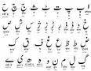 | Click on the link below to book your place  http://www.traffordlearning.org/cpd/CPDCourseForm.asp  CPD Unit, Education and Early Years Services  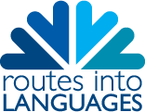  T: 07810487186  