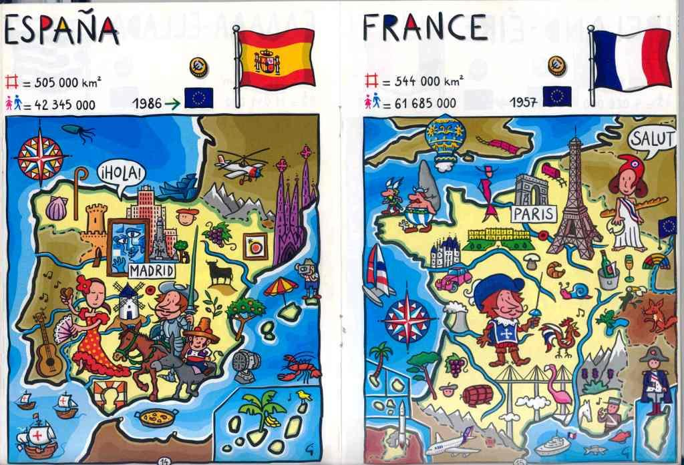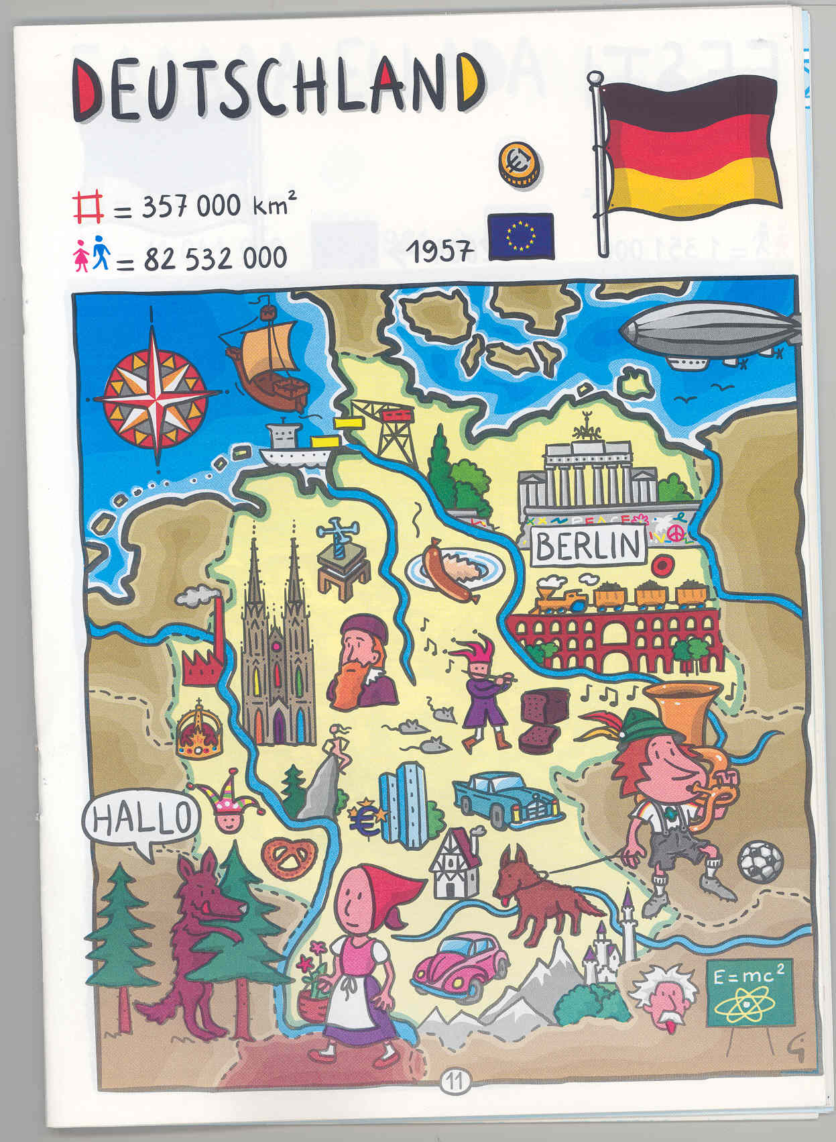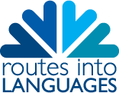
Routes into languages

Programme of Events 2008

Sea, Hear – Languages at Sea: the ArtemisTransat Yacht Race in Plymouth Tuesday 6th May – Friday 9th May 9am – 5pm University of Plymouth Marquee, ArtemisTransat Race Village, Sutton Harbour, Plymouth Quizzes and interactive activities for Year 7, 8 and 9, on a nautical theme.

French and Spanish Languages Taster Day for Year 9 Wednesday 14th May 2008 10am – 3pm University of Plymouth Business School E-learning language sessions and fun activities for Year 9 pupils, including a European Quiz.

German Language Day – Put a little German into Your Life! For Year 10 Monday 2nd June 2008 10am – 3pm University of Plymouth Business School
With the participation of the Goethe Institute, London. Includes language improvement sessions and a range of activities for Year 10 pupils.

