

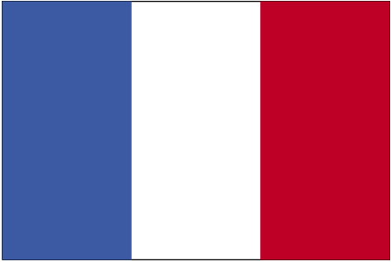
Designed by:
Dr Ian McCall
University of Southampton

Clare Forder
Routes into Languages
South Consortium



